Mission Report
2020/06/03 (Wed.)

Preparing for a potential Mei-yu IOP during the official TAHOPE campaign
Ming-Jen Yang

Mission: “Virtual” Mei-yu IOP

Scientific Discussions: For the past two days, the CWB forecast team has been reviewing a previous Mei-yu case about two weeks before the start of the TAHOPE Dry Run campaign as the conditions over the TAHOPE research domain is expected to remain stable. The forecasters presented the environmental conditions on 21 May 2020 and the forecast from 22 May to 24 May. The forecaster showed a surface wind shift line over northern Taiwan that is expected to propagating gradually to the south in the next few days. Intensifying low-level moisture transport over Taiwan Strait raised the potential for widespread, heavy rainfall within the main TAHOPE research domain for the upcoming days.

The TAHOPE/PRECIP PIs participating in the remote conference agree that if similar conditions exist during the official TAHOPE campaign, it will be preferable to have an IOP to observe this potential rainfall event. Observations on this event could be focus on documenting the environmental conditions upstream of Taiwan, specifically the moisture and wind profiles within the lowest 1-2 km. Instrumental assets located in Taiwan could be used to observe the environmental conditions near the front with greater temporal resolution, this observation could then be used to improve model predictability on Mei-yu frontal movement.

Deployment strategy: Assuming everything goes as planned during the official TAHOPE campaign, a couple of deployment decisions would be made for this IOP. All TAHOPE sounding sites are requested to launch extra soundings throughout the day, but especially for the Dongsha Island and the southern Taiwan sites. If there is enough DOTSTAR flight hours left in our disposal, we should also consider the possibility to do one or two flights in the general area of southwestern Taiwan and northern South China Sea (black dotted area “A” in Fig. 1). The purpose of these flights would be to sample the upstream environment of the Mei-yu front. While there are some model disagreements with regard to the convective activity in northern Taiwan, radiosonde sites there should also prepare to launch extra soundings. The objective for observations in the red-dotted area “B” in Fig. 1 would be to sample the small-scale features and time evolution of the southward-propagating Mei-yu front and associated convection. Radar platforms in this area (SPolKa, two mobile radars from NTU and NCU, the CSU SEA-POL radar) could consider performing synchronized scannings and performing some RHIs to sample the vertical structures of the front. Observations from profilers and vertical-pointing radars near Hsinchu would also be beneficial in accomplishing the observation objectives.

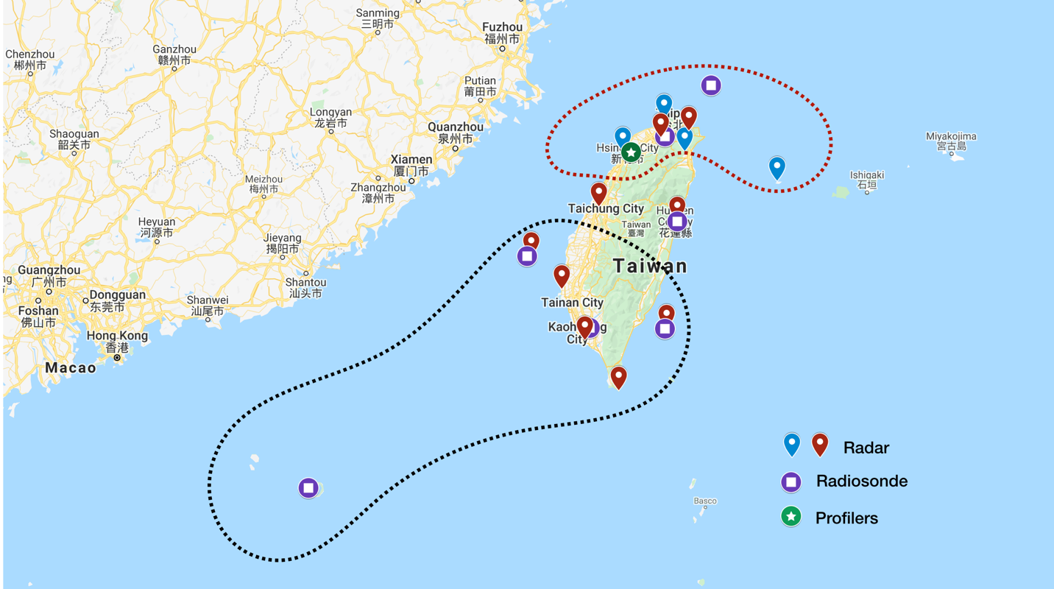
A
B

Fig. 1: An overview of the TAHOPE research domain and locations of main TAHOPE observation facilities. Dotted areas are the two general intense observation areas for this proposed IOP.

