TAHOPE Weather Summary
Date(UTC): 2019/06/12 02:15
Author: Todd,
Submitted at(UTC): 2019/06/12 08:30
Revised at(UTC):

REVIEW OF YESTERDAY'S FORECAST:
昨(11)日鋒面位於臺灣北部陸地，臺灣各地降水明顯增加，尤其西半部地區普遍有大雨或豪雨發生，今(12)日鋒面南移至臺灣南部陸地，臺灣南部陸地仍有較強降水，唯環境已漸不利強對流系統發展。

The stationary front was at northern Taiwan. It was rainy all over Taiwan especially some area of Western Taiwan got torrential rainfall or heavy rainfall. The from is now at Southern Taiwan and there is still heavy rainfall in southern Taiwan, though the environment is not as good as for development of deep convection yesterday.

***

DAY 1 (06.12) UPDATE:
Date: 06/12 00 UTC
Image 1：衛星雲圖及雷達回波疊加模式地面風場與海平面氣壓場顯示，隨著東海之反氣旋持續東移且略向南移動，東北風之範圍亦持續南移，地面鋒面遂已移至臺灣南部陸地，故降水回波多位於臺灣中部以南地區活動，然回波強度已不如昨(11)日為強。

Image 2：850hPa風切線(鋒面)南移至臺灣中部陸地，受地形影響，氣旋式風切已不甚顯著，南海(風切線南側)一帶風速約10~20kts，西南風風速偏弱；潛在不穩度(1000-700 theta-E lapse rate)分析顯示，潛在穩定之區域已由臺灣北部海面延伸至臺灣海峽與臺灣西半部陸地，不穩度逐漸釋放。

Image 3：臺灣附近因低層風速減弱，故1000~850hPa水氣通量降低，然海峽南部仍有水氣通量輻合，使該處較有利降水系統發展。

Image 4：500hPa槽線東移至日本附近，不直接影響台灣地區天氣，然槽後低層之東北風卻不易使鋒面北抬。200hPa分流較明顯處位於華南，若低層有forcing，則該處相對有利深對流發展。

Image 1 :As the anticyclone at East China Sea moves southeastward, the front is now at southern Taiwan and moving southward. Radar image shows most precipitaion area is around Central and Southern Taiwan. However the radar reflectivity signal is no as strong as yesterday.

Image 2 : Shear line at 850hPa is at Central Taiwan and weaken due to impact of topography. 15-20 kts Southwesterlies prevails over northern South China Sea, windspeed weakens gradually. Due to the southward movement of the front, Western Taiwan become convective stability according to the distribution of equivalent potential temperature’s lapse rate.

Image 3：Due to weakening of windspeed, moisture transport between 1000-850hPa around Taiwan decreases. But there is convergence of moisture transport around souther Strait which is suit for development of convection system.

Image 4：Taiwan is now at the upstream of the tought at Japan, and the low level northeasterlies triggered by the trough makes stationary front stay around Southern Taiwan. Divergence at 200hPa is significant around Southern China which is good for development of deep convection.

***

DAY 2 (06.13) FORECAST:
Date: 6/13 12 UTC
Image 5：13日晚起，臺灣北部海面將有旋生，並伴隨鋒生過程，故臺灣附近之降水系統將再度活躍，於此之前，降水稍趨緩。

Image 6：850hPa於臺灣北部海面亦有旋生現象，故西南風開始增強，臺灣海峽北部至臺灣北部海面風速達25~35kts；潛在不穩度(1000-700 theta-E lapse rate)分析顯示，隨著低層西南風增強，平流較高不穩度之空氣至臺灣地區，大氣環境再度有利對流系統發展。

Image 7：臺灣附近因低層旋生，故風速增強，因此1000~850hPa水氣通量升高，較顯著之水氣通量輻合區位於臺灣北部海面，即旋生處，使該處較有利降水系統發展。

Image 8：500hPa槽線位於華東，將逐漸東移加深，臺灣地區位於槽前，故臺灣北部海面有旋生並伴隨鋒生現象。200hPa分流較明顯處位於華南，若低層有forcing，則該處相對有利深對流發展。

Image 5：There is no siginificant precipitation signal around Taiwan until the evening of June 13 while a low deepens around the sea of northern Taiwan.

Image 6：Due to the deepening of the low, southwesterlies at over the sea around northern taiwan at 850hPa intensifies to 25-35kts. The environment turns to convective instability because southwesterlies advects the air with higher convective instability to Taiwan.

Image 7：Due to the progress of cyclogenesis, southwesterlies intensifies and moisture transport enhances. Significant convergence of moisture transport near the area of cyclogenesis raises the potential of development of deep convection.

Image 8：A deepened trough at eastearn China moves eastward. Taiwan is at upstream of the trough, thus a cyclogenesis at the sea of northern taiwan companies with frontogenesis. Significant upper level difuluence is over southern China makes potential of development of deep convection.

***

LONG TERM OUTLOOK:
Image 9：NCEP(左)與EC(右)對於14日之降水預報趨勢逐漸一致，兩者均顯示位於臺灣北部近海有旋生，然EC預報之旋生強度仍較強且較靠近臺灣陸地，其伴隨之現象為海平面氣壓較低，風速較強，850hPa西南風偏強，500hPa槽線亦較深，故整體環境有較強之forcing引發降水，反之，NCEP此旋生強度較弱亦較快東移，故降水較少，然預報仍有不確定性，需持續觀察。

Image 10：由左上順鐘向至左下，依序分別為NCEP、EC、TWRF、WRF模式之預報，各模式均顯示週五(6/14)降水將增多，同為旋生與鋒生所致，預計此氣旋鋒面系統東移較快，並無長時間滯留於臺灣附近之趨勢，故累積降水量相對較少，然預報仍有不確定性，需持續觀察。

Image9: The trend of precipitation gets consensus between NCEP and EC. Both model show a cyclogenesis processes near the sea of northern Taiwam. However, the cyclogenesis in EC is much closer to Taiwan and much more intense than that of NCEP. Futhermore, a stronger southwesterlies and deeper trough in EC model may cause higher potential of heavy precipitation then NCEP. There are stiil some differences between 2 models which is needed to be watched.

Image10: NCEP, EC, TWRF and WRF models all show precipitation will increase on June 14. However the front which brings precipitaiton move eastward quickly, accumulated precipitation won’t be very much due to short duration of heavy precipitation.
***

Image 1
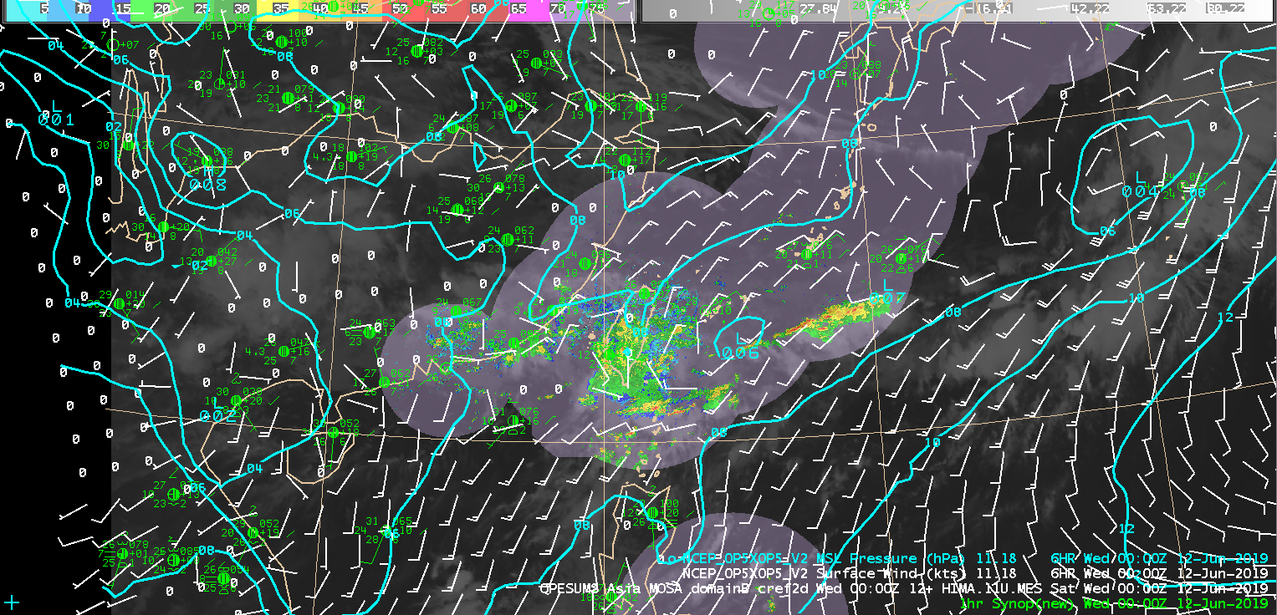
Image 2
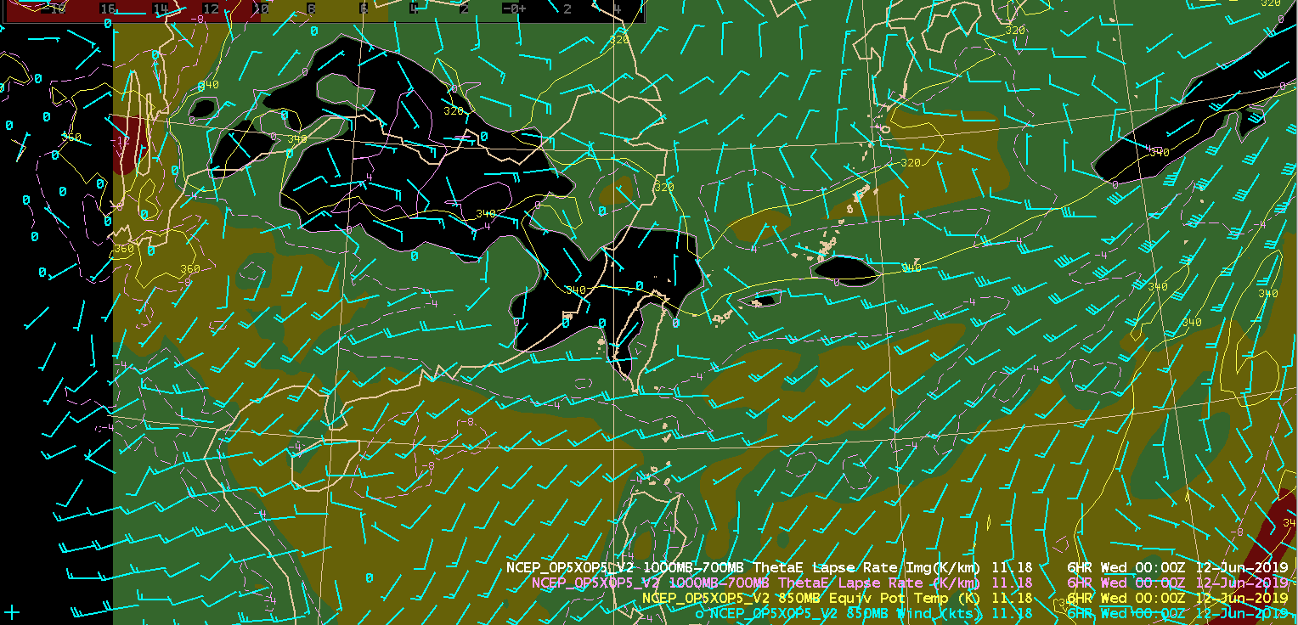

Image 3
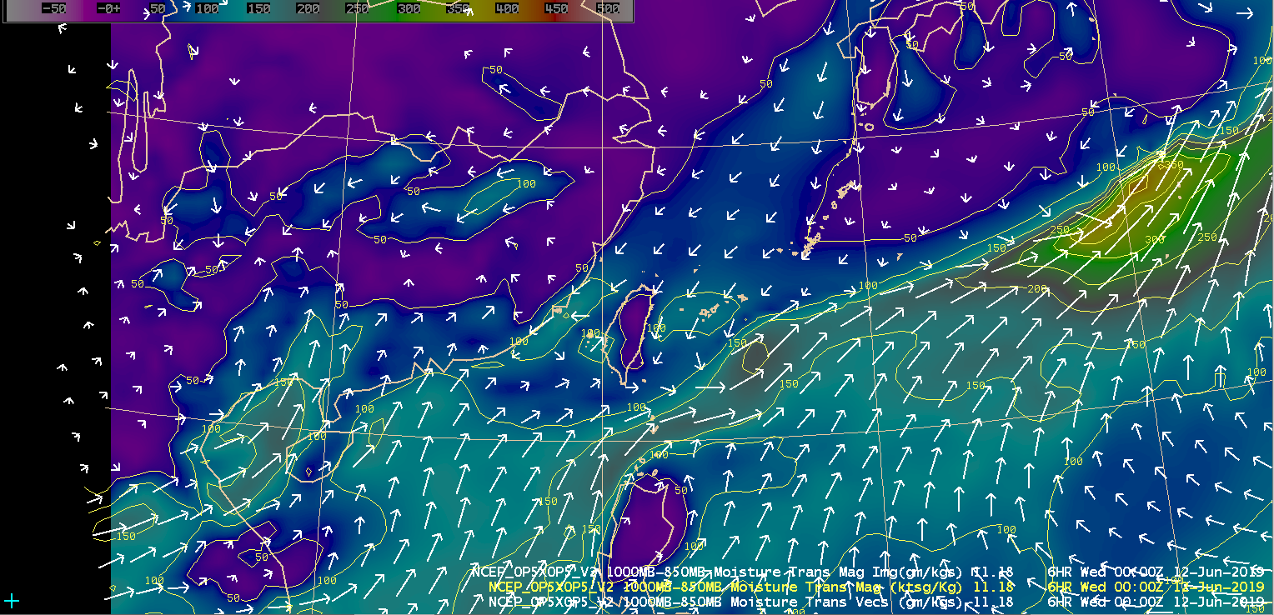

Image 4
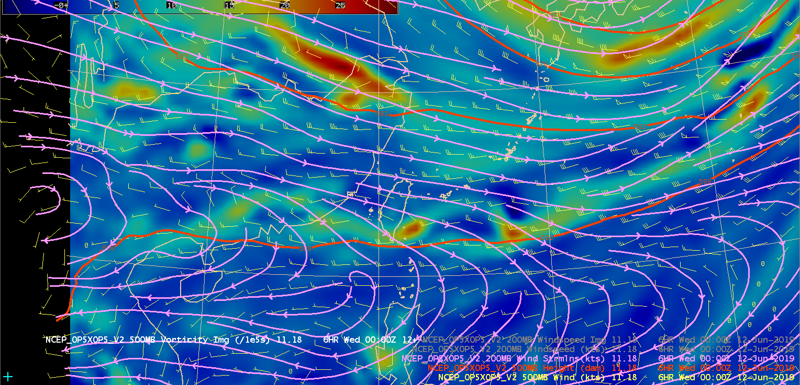

Image 5
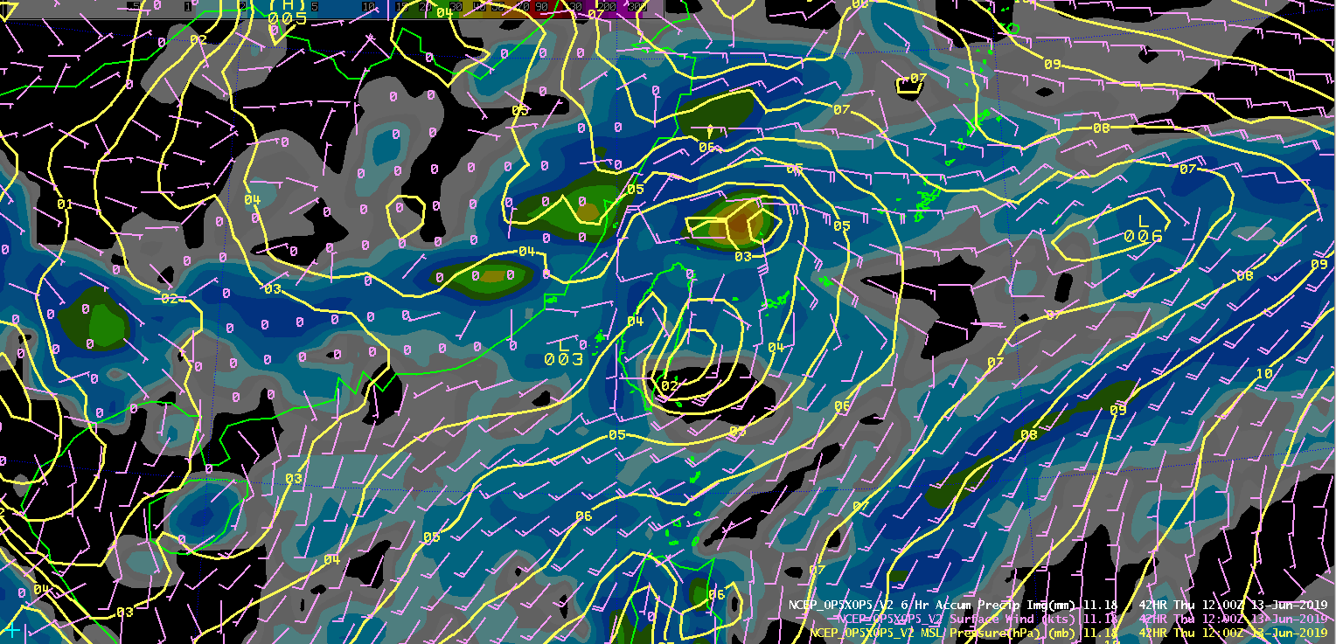

Image 6
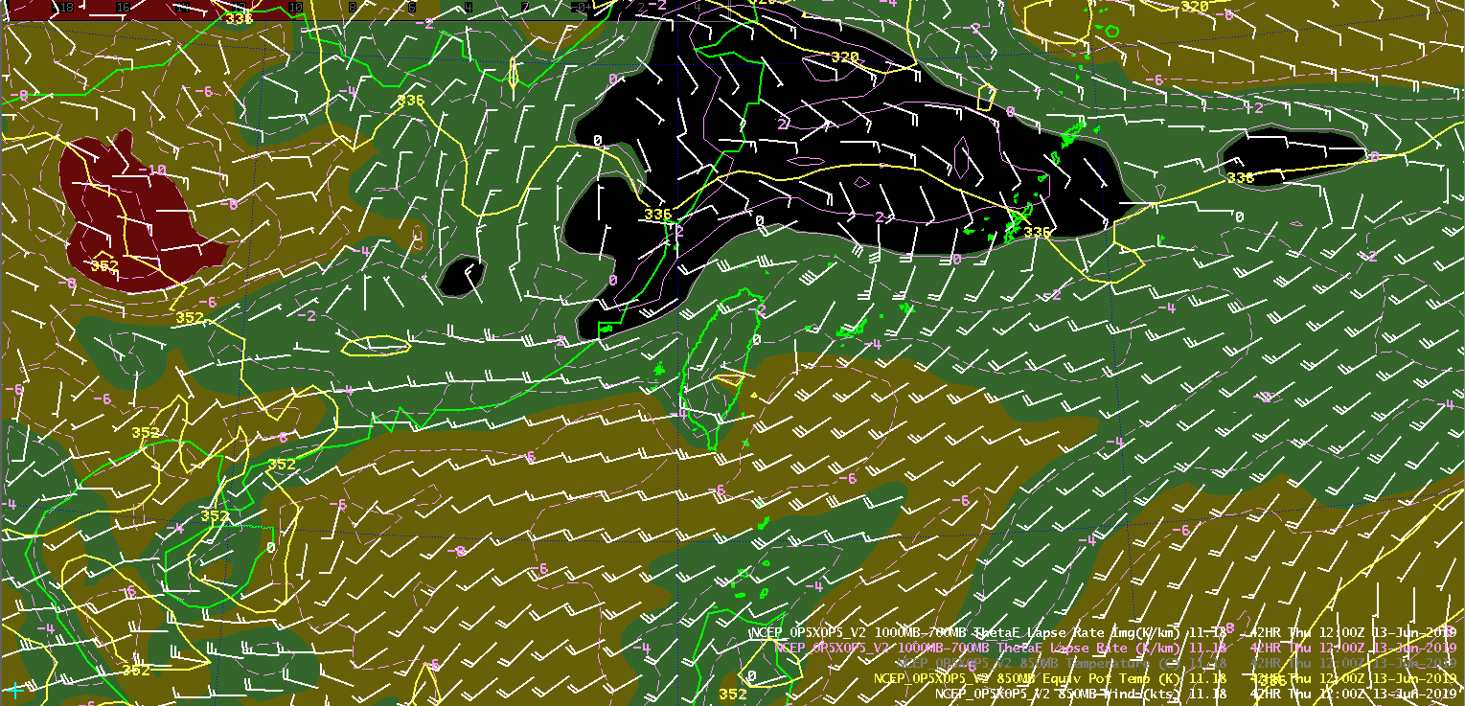

Image 7
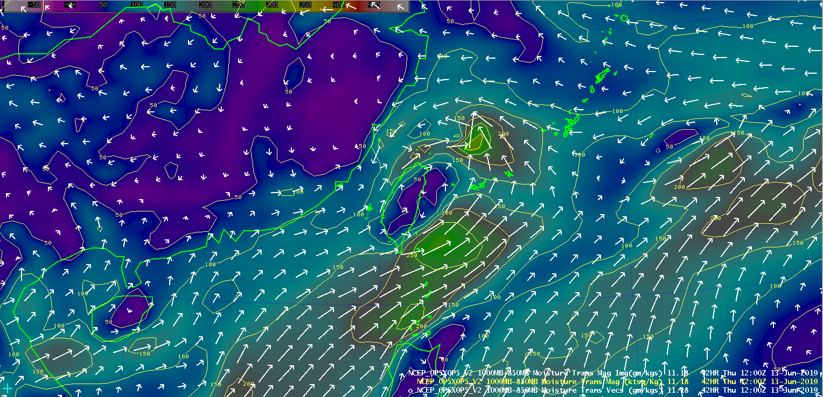

Image 8
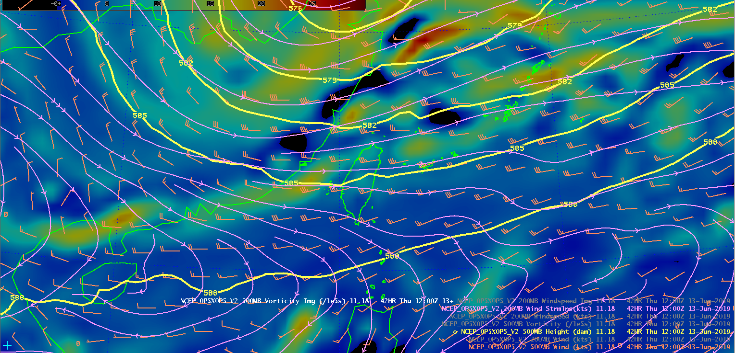

Image 9
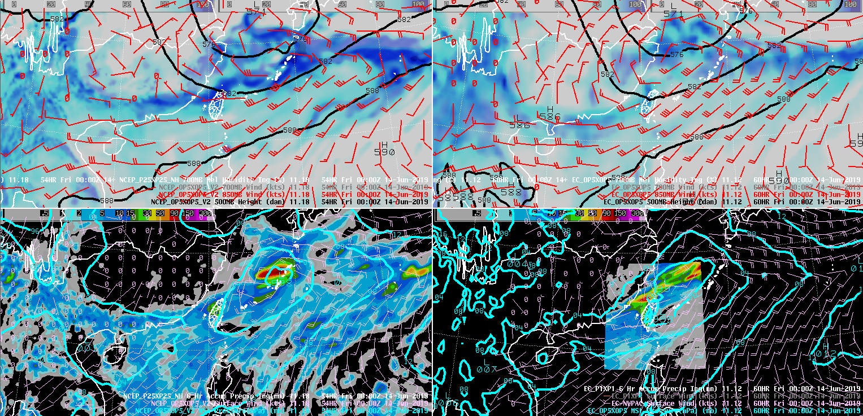

Image 10
