TAHOPE Weather Discussion (2020-06-03)
Date (UTC): 2020/06/03 2:15
Forecaster: Chieh-Jen Cheng (CWB)
Author: Frederick Iat-Hin Tam (NTU)

Debrief of yesterday’s (05/20) forecast:
QPESUMS 24-h QPE for 20 May shows broad areas of strong precipitation near south-western Taiwan and relatively limited precipitation in Northern Taiwan (Fig. 1). The stationary front was at northern Taiwan. Validations with various model products reveal large discrepancies in the forecast precipitation distributions. Regional models, like the 3 km resolution WRF-D and TWRF, generally did a better job than global models in forecasting the 20 May rainfall event. Specifically, the weaker precipitation in Northern Taiwan was better captured by the regional models than the global models, which generally over-predicted the rainfall over Northern Taiwan.

Summary: Active convective development over much of the TAHOPE research domain is anticipated owing to (i) robust upstream moisture transport and (ii) possible low-level lifting associated with wind shear line over northern Taiwan. The wind shear line is expected to gradually move southward, thereby initiating a similar southward movement in the accumulated rainfall over the extended forecast period. There is substantial variance in the timing and speed of this southward propagation, however.

Day 1 (21 May) update: 0.25º NCEP surface wind field shows the existence of a surface wind shift/shear line in southern China that extended towards northern Taiwan (Fig. 2a). Himawari-8 satellite imagery (Fig. 2a) shows the development of multiple mesoscale convective systems (MCSs) along the surface wind shift line, the strongest one being the one located south of Hong Kong. A low-pressure area over northern Vietnam likely contributes to the intensification of the southerly flow. Upstream environment of Taiwan could be characterized by strong low-level flow (wind speed in excess of 20 knots) and substantial convective instability, as indicated by the 1000-700 hPa equivalent potential temperature lapse rate (Fig. 2d). Relatively south-westerly flow upstream of Taiwan enhances the low tropospheric (1000-850 hPa) moisture transport (Fig. 2b). Diffluent flow at 200 hPa (Fig. 2c) could also make it more likely for deep convection to develop.

Day 2 (22 May) outlook: The surface wind shear line is expected to persist over southern China, Taiwan Strait, and northern Taiwan at 06 UTC (Fig. 3a), bringing sufficient low-level triggering mechanism for deep convection. An intensification of 850 hPa south-westerly wind over the Taiwan Strait (Fig. 3d, wind speed in excess of 30 kts) is expected to enhance the low-tropospheric moisture transport compared to 21 May (Fig. 3b).

Six hours later (12 UTC), the deterministic NCEP forecast appears to show a localized southward shift in wind shear line over Taiwan Strait. This southward movement is most prominent at the surface (Fig.4d). The low-tropospheric moisture transport contracts slightly compared to 06 UTC and is strongest near southwestern Taiwan (Fig. 4b).

Extended Outlook: The deterministic NCEP forecast continues to show a southward propagation of surface wind shear line at 06 UTC and 12 UTC, 23 May (Fig. 5a, 6a). Apart from the southern tip of Taiwan, wind speed at 850 hPa is expected to decrease on 23 May (Fig. 5d, 6d). Accompanied with the changes in wind field is the southward shift in low-tropospheric moisture transport: large low-level moisture transport values (>200 gm/kgs) can only be found near southwestern Taiwan at 06 UTC 23 May (Fig. 5b) and the southernmost tip of Taiwan six hours later (Fig. 6b). The same tendency in low-level wind and moisture transport is expected to persist by 00 UTC 24 May (Fig. 7a,b,d).

Discussion
Mei-yu precipitation: Figure 8 shows the quantitative precipitation forecast (QPF) for two global models (EC, NCEP; first and second row) and regional models (WRFD, TWRF; third and fourth row), respectively. There are substantial disagreements between the models on the rainfall distributions of this event: the NCEP model and two regional models predict band-like heavy precipitation near southwestern Taiwan, with significant topographical enhancement component. Predicted rainfall by the EC model is further to the north than the other models, the southwestern rainband is also weaker than the other models.

All models show a gradually southward propagation in the rainfall area over the next 2-3 days. The models, however, seems to disagree on the speed of this southward movement. Apart from possible location bias, the wind shift line in the EC forecasts moves in a slower rate than the other three models. This allows strong precipitation to occur in both central and southern Taiwan over the extended forecast period, whereas strong precipitation is limited in southern Taiwan in the other models.
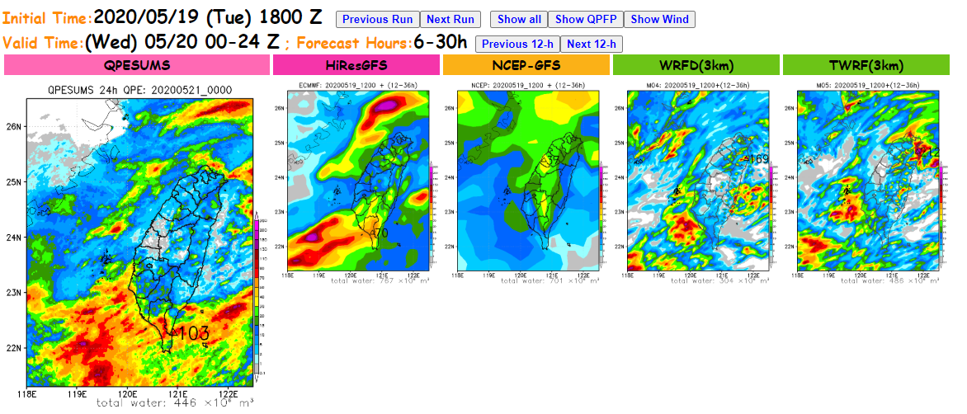
Figure 1. QPESUMS 24-h accumulated rainfall valid at 21 May 2020 00UTC (leftmost panel) and forecast 24-h accumulated rainfall for four different models over the same period.

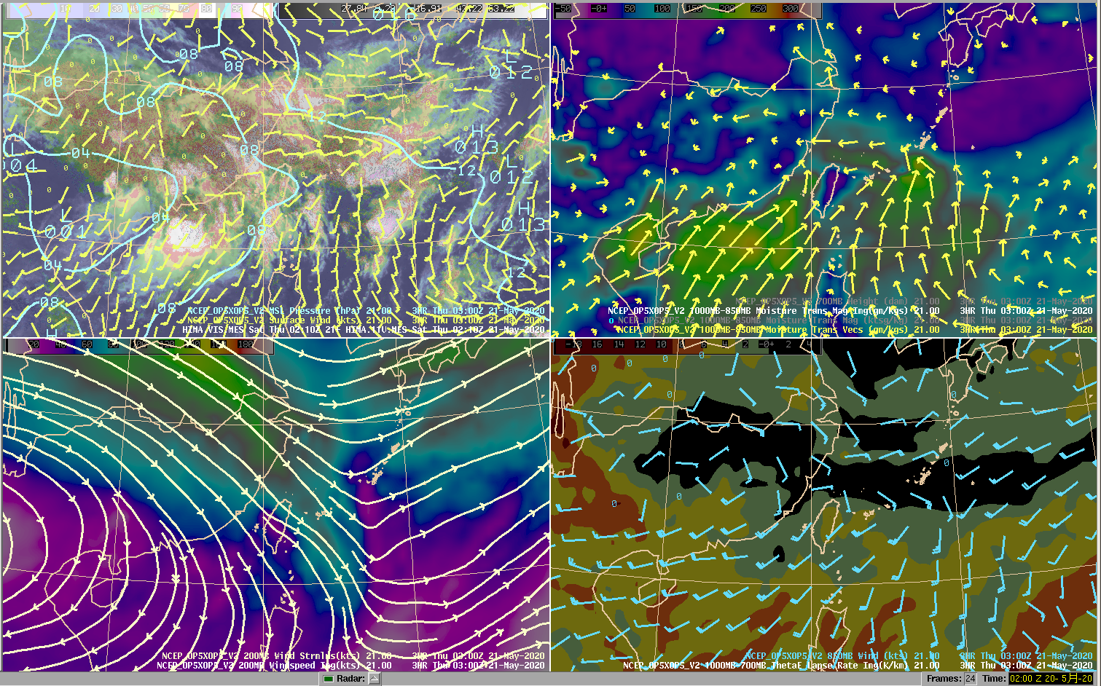
d.
c.
b.
a.
Figure 2. 0.25º NCEP analysis of (a) surface wind (barbs), pressure (blue contours) and Himawari-8 visible channel imagery (shading). (b) 1000-850 hPa moisture transport (shading, vector). (c) 200 hPa wind field (streamline), wind speed (shading). (d) 850 hPa wind field (barbs), 1000-700 hPa theta-e lapse rate (shading). All products are valid at 03UTC on 21 May 2020,

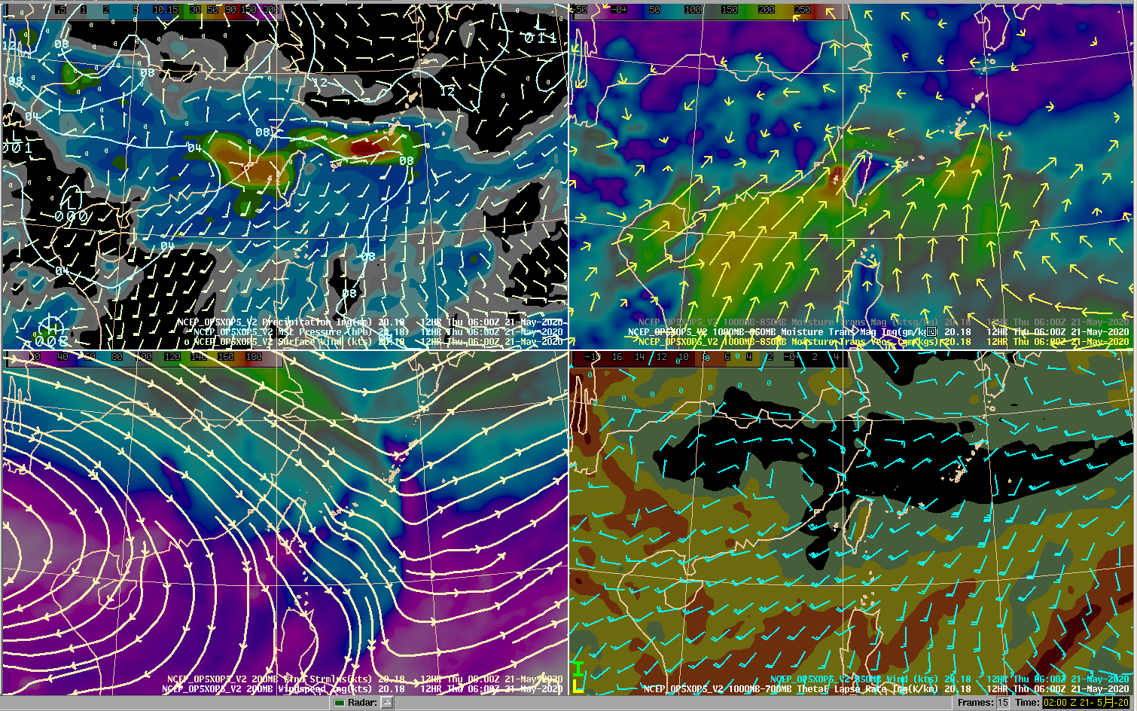
d.
c.
b.
a.
Figure 3. 0.25º NCEP 12-h forecast of (a) surface wind (barbs), pressure (blue contours) and precipitation (shading). (b) 1000-850 hPa moisture transport (shading, vector). (c) 200 hPa wind field (streamline), wind speed (shading). (d) 850 hPa wind field (barbs), 1000-700 hPa theta-e lapse rate (shading). The forecast is valid at 06 UTC 21 May 2020.

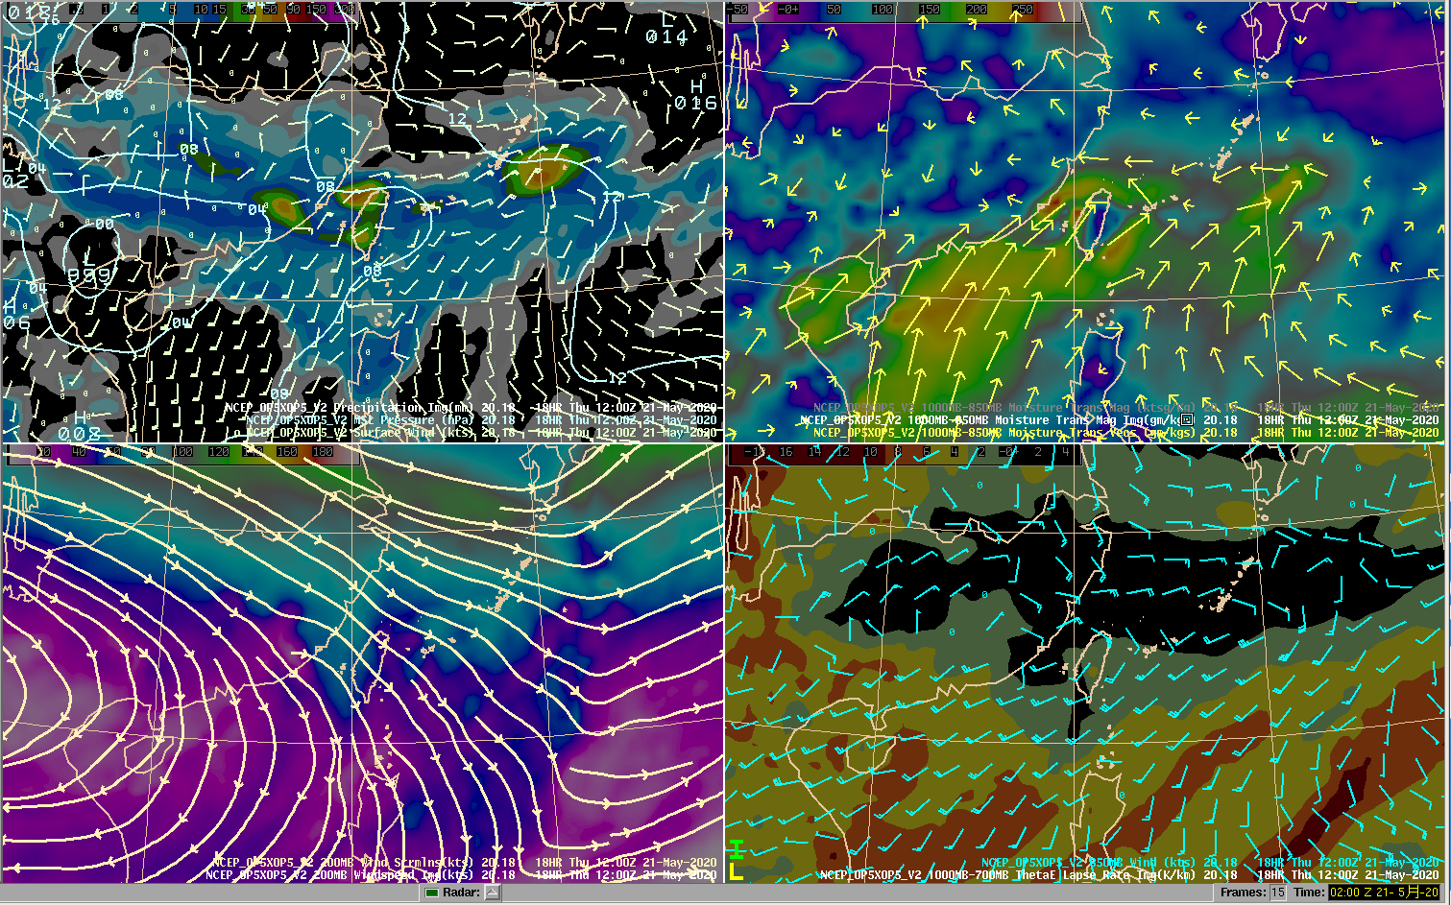
d.
c.
a.
b.
Figure 4. 0.25º NCEP 18-h forecast valid at 12 UTC 21 May 2020. Variables shown in the panels are the same as Figure 3.

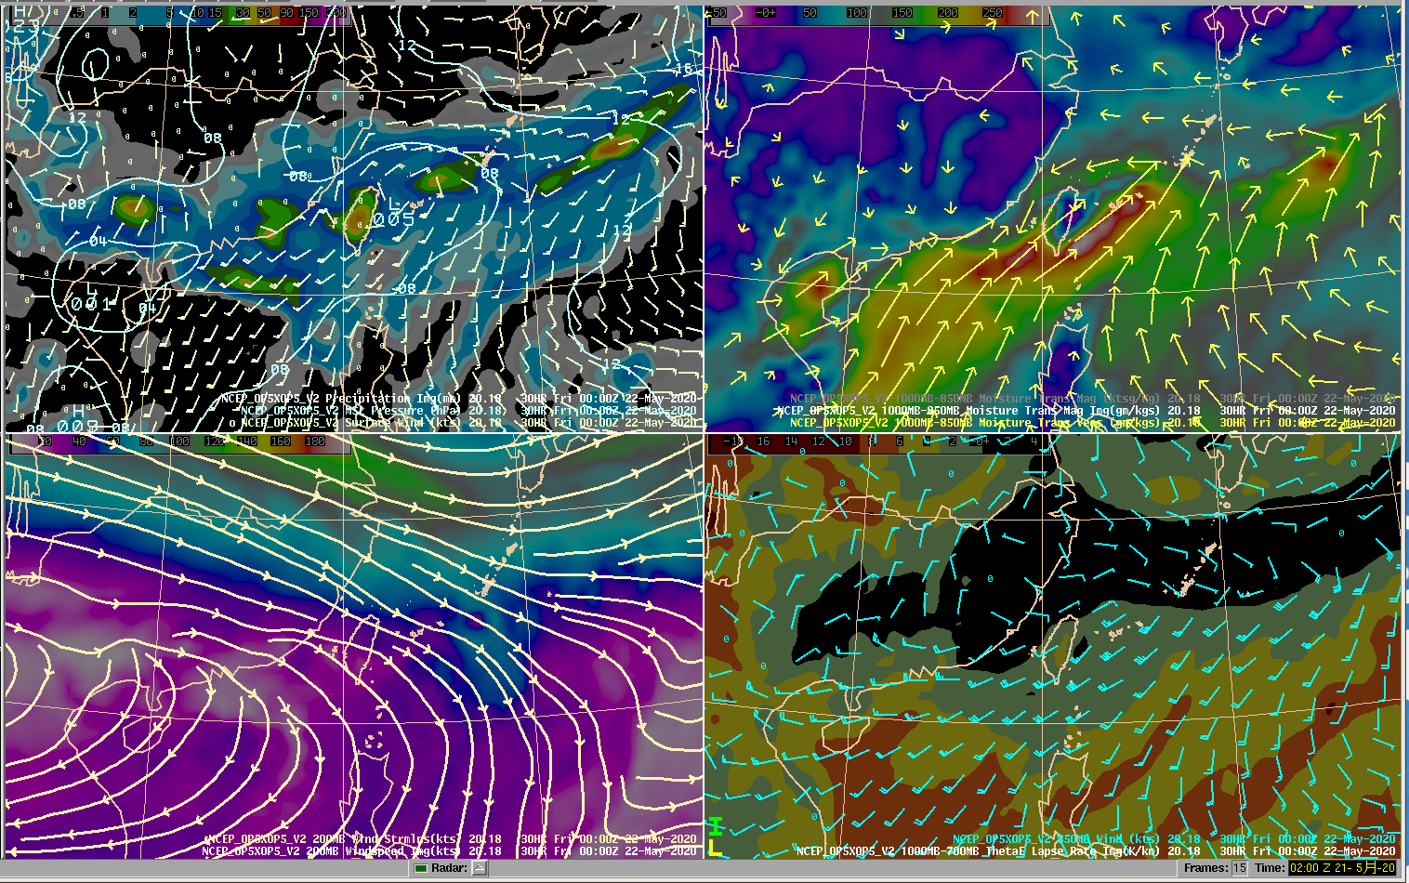
d.
c.
b.
a.
Figure 5. 0.25º NCEP 30-h forecast valid at 00 UTC 22 May 2020. Variables shown in the panels are the same as Figure 3.

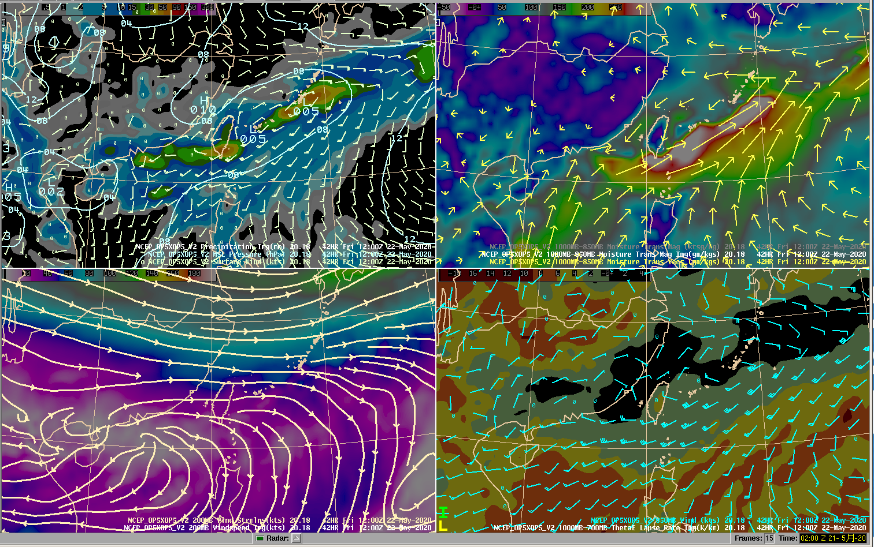
b.
a.
c.
d.
Figure 6. 0.25º NCEP 42-h forecast valid at 12 UTC 22 May 2020. Variables shown in the panels are the same as Figure 3.

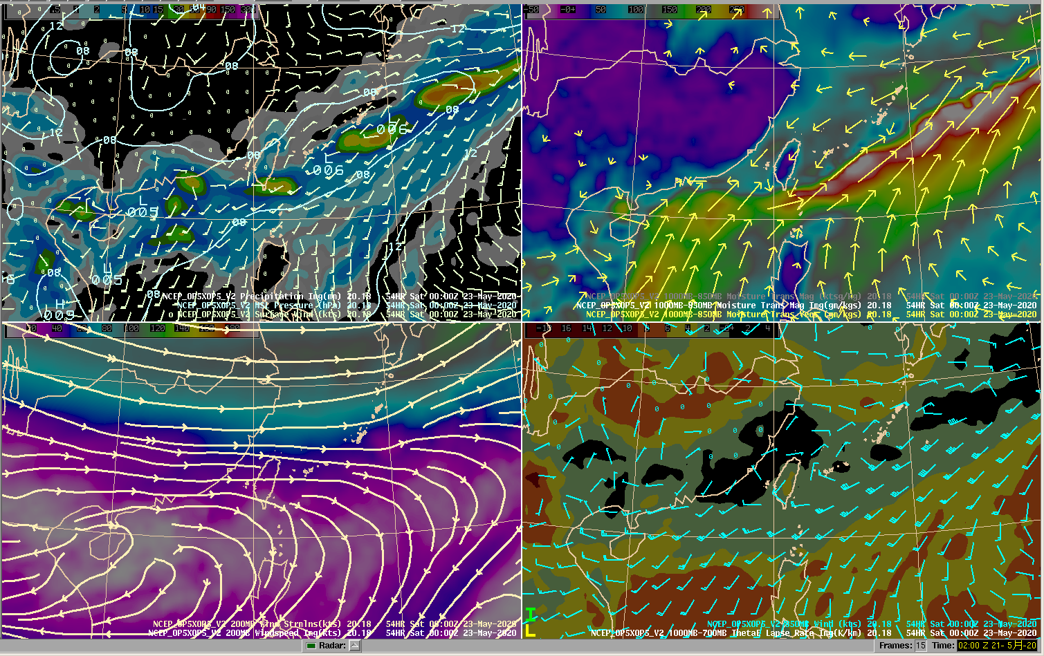
b.
a.
d.
c.
Figure 7. 0.25º NCEP 54-h forecast valid at 00 UTC 23 May 2020. Variables shown in the panels are the same as Figure 3.

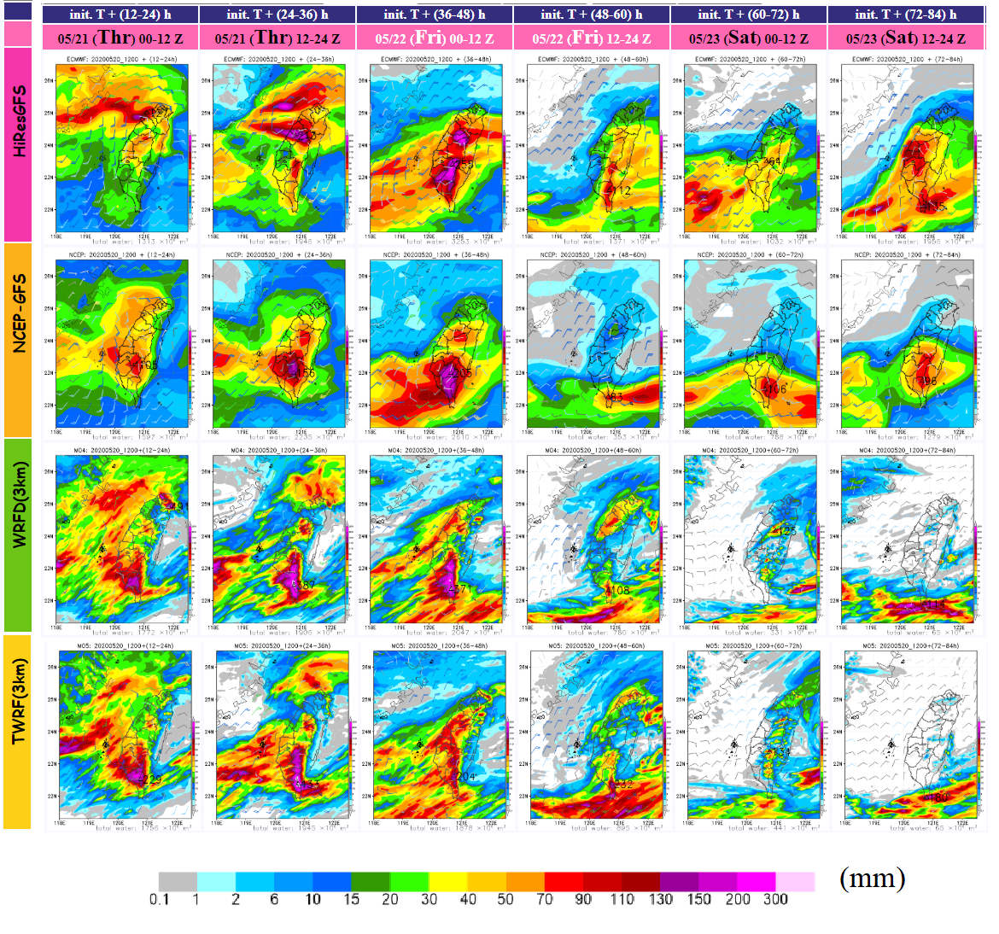
Figure 8. Quantitative precipitation forecast (QPF) from 00 UTC 21 May 2020 to 00 UTC 24 May 2020 (84 hour forecast).

