TAHOPE Weather Discussion (2020-06-05)
Date (UTC): 2020/06/05 2:15
Forecaster: Hsin-hua (CWB)
Author: Frederick Iat-Hin Tam (NTU)

Summary: The currently calm and stable conditions over much of Taiwan is expected to change in the next few days as a surface frontal boundary is forecasted to move gradually to south throughout the remainder of the week. Due to favorable synoptic and low-level forcing, this Mei-yu event has the potential in being relatively active and intense. Expansion of subtropical high is responsible for a forecasted lull after next Monday (8 June).

Day 1 (5 June) update: Himawari-8 visible channel satellite imagery (Fig. 1) indicates multiple areas of deep convection in central China and the Okinawa Islands. These deep convective systems are related to a surface frontal area in central China that extends towards the south of Japan. Since the frontal area is currently too far north with respect to the main TAHOPE research domain, the weather pattern for Taiwan remains calm and relatively stable.

Day 2-3 (6-7 June) outlook:
General Outlook:
Global model guidance (Fig. 2-3) for the next 48 hours is showing a gradual tendency for the surface frontal area to move slightly to the south. This will enhance the low-level instability and provide an avenue of low-level lifting for the TAHOPE domain, which will presumably generate some precipitation over Taiwan. For the synoptic perspective, Taiwan will be located downstream of a trough at 500 hPa (Fig. 4) for the next 24 hours. This could provide some synoptic upward movement, thereby favoring the initiation, sustenance, and intensification of rainy systems near Taiwan on 6 June. While the trough is expected to past Taiwan on 7 June, 500 hPa vorticity field still suggests active convective activity on the 7th.

Examination of low-level forcing:
Comparing the low-level wind field and moisture transport characteristics predicted by the global model (Fig. 6-7) shows an increase in southwesterly flow intensity to ~30 knots upstream of Taiwan. This southwesterly flow intensification precedes the southerly surface front movement. The combination of positive 500 hPa vorticity advection (since it is downstream of 500 hPa trough) and enhanced low-level moisture transport upstream of Taiwan could provide favorable forcing for precipitating system development on the 6th. For the 7th, the surface front is expected to continue to close in on Taiwan. 850 hPa wind is forecasted to weaken slightly and there is a slight hint of a convergence zone in the vicinity of Taiwan. The environmental forcing for precipitation system development is forecasted to be concentrated to the low-levels since Taiwan will be located behind the mid-level trough by 7th.

Discussions on model precipitation forecasts: It is apparent from the model QPFs (Fig. 8) that there is will be a potential precipitation event from 6 June to 8 June, with the strongest precipitation likely occurring during the weekend (6 June-7 June). The models still have substantial disagreements on the type of these precipitation, with the EC showing comparable contributions from frontal precipitation and afternoon thunderstorms over elevated terrain, and the other models (especially the regional models) showing a predominately afternoon thunderstorm-dominated rainfall pattern. For the extended forecast period, the two global models are showing a drying tendency and gradual subsidence of precipitation activity. This tendency is most apparent in the EC model owing to its stronger and more expanded subtropical high.

Guidance for decision making:

Day 1:
Confidence | Area and phenomenon | Possible time period | Rainfall estimate
Moderate | A: Afternoon thunderstorms near TW terrain | 6:00-12:00 | 30-70mm

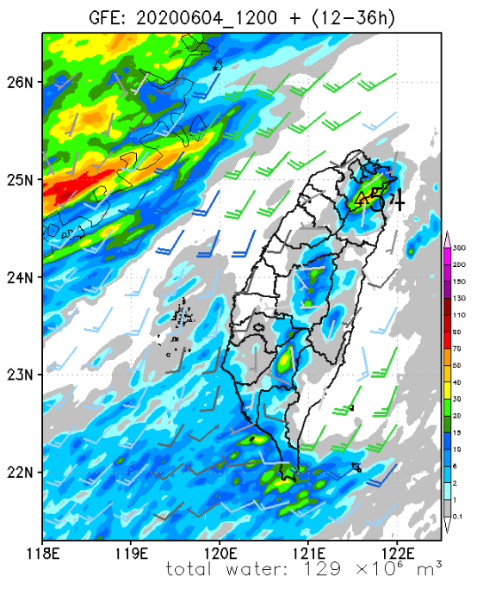

A

Day 2:
Confidence | Area and phenomenon | Possible time period | Rainfall estimate
High | A: Afternoon Thunderstorms | 6:00-12:00 | 50-100mm
Low | B: Mei-yu frontal precipitation |  | 30-90mm

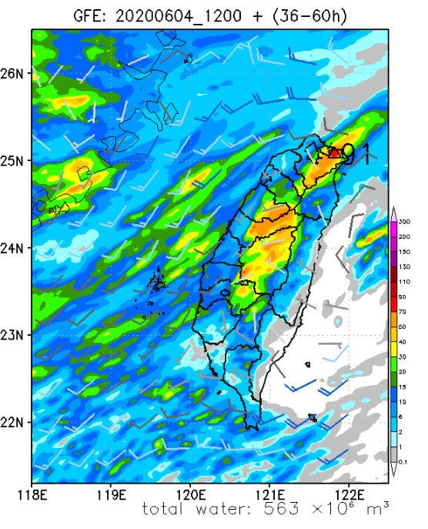

A

B
Day 3:
Confidence | Area and phenomenon | Possible time period | Rainfall estimate
High | A: Afternoon Thunderstorms | 6:00-12:00 | 50-100mm
Moderate | B: Mei-yu frontal precipitation | 00:00-24:00 | 30-150mm
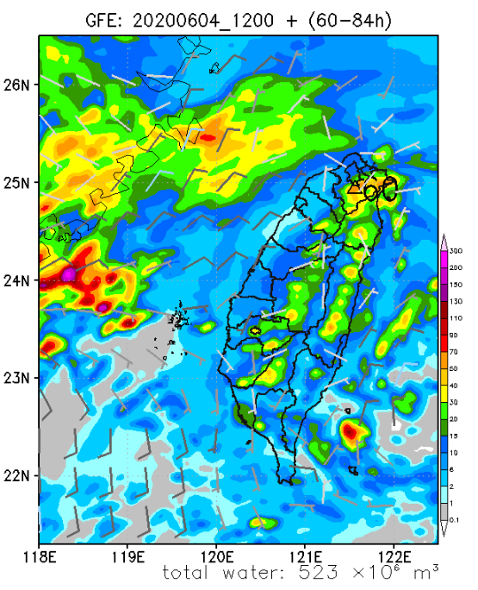

A

B
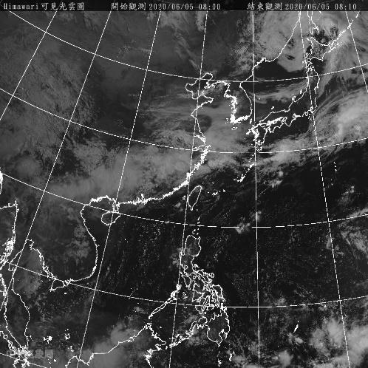

Figure 1. Himawari-8 visible channel imagery (shading) valid at 00 UTC 5 June 2020.

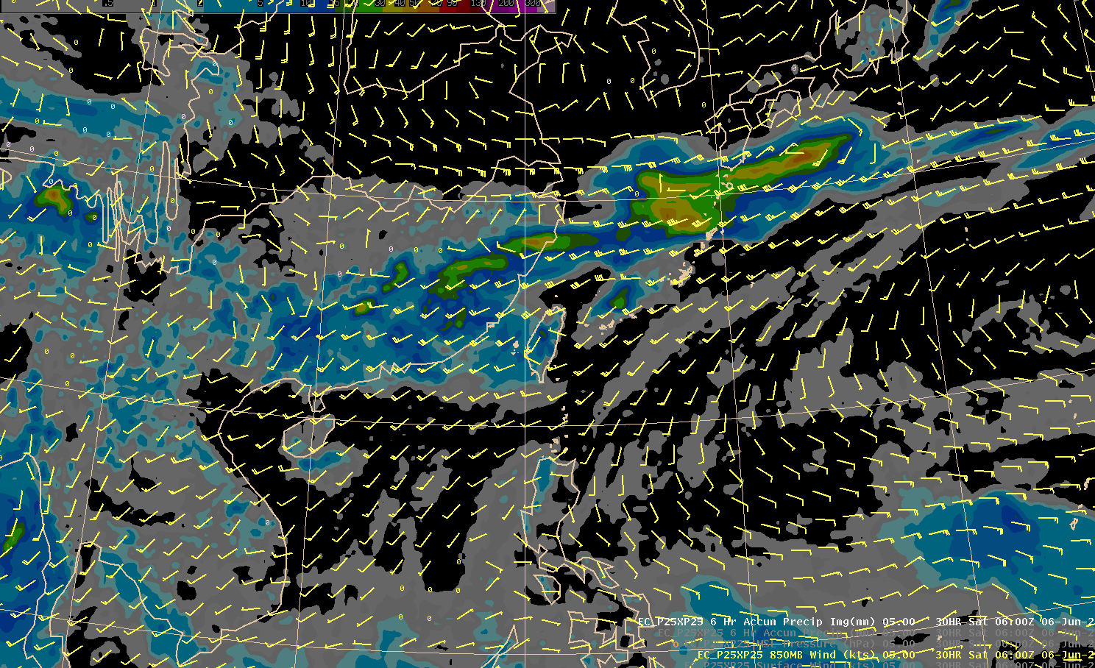

Figure 2. EC 850 hPa wind (barbs) and precipitation (shading) valid at 06 UTC 6 June 2020.

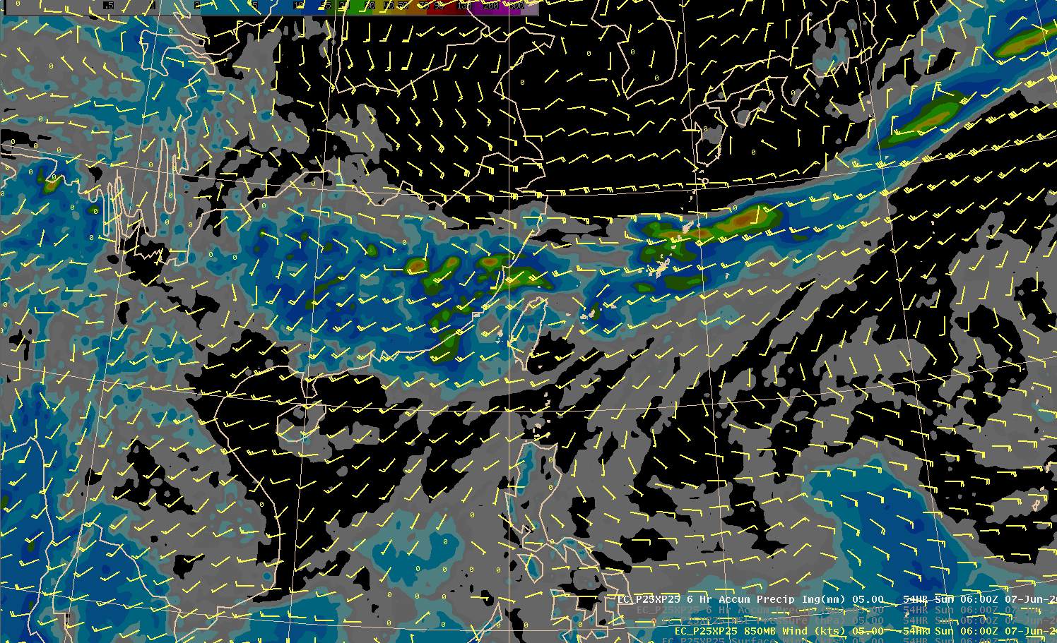

Figure 3. Same as Figure 2, but valid at 06 UTC 7 June 2020.

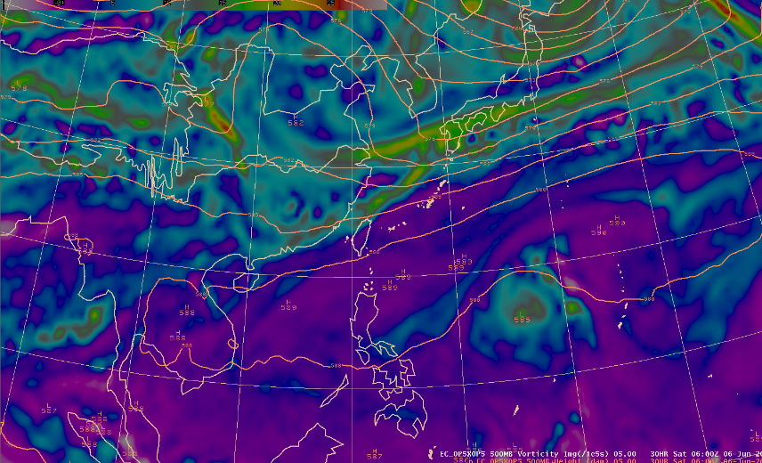

Figure 4. EC 500 hPa height (contours) and vorticity (shading) valid at 06 UTC 6 June 2020.

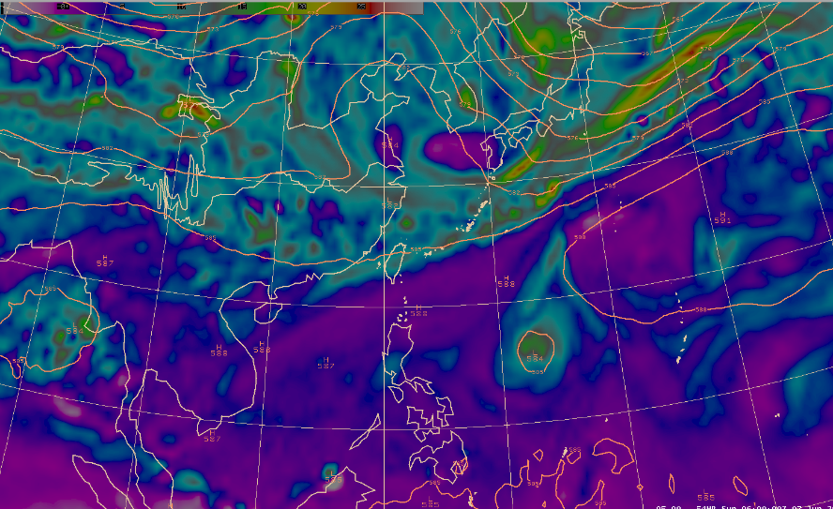

Figure 5. Same as Figure 4, but valid at 06 UTC 7 June 2020.

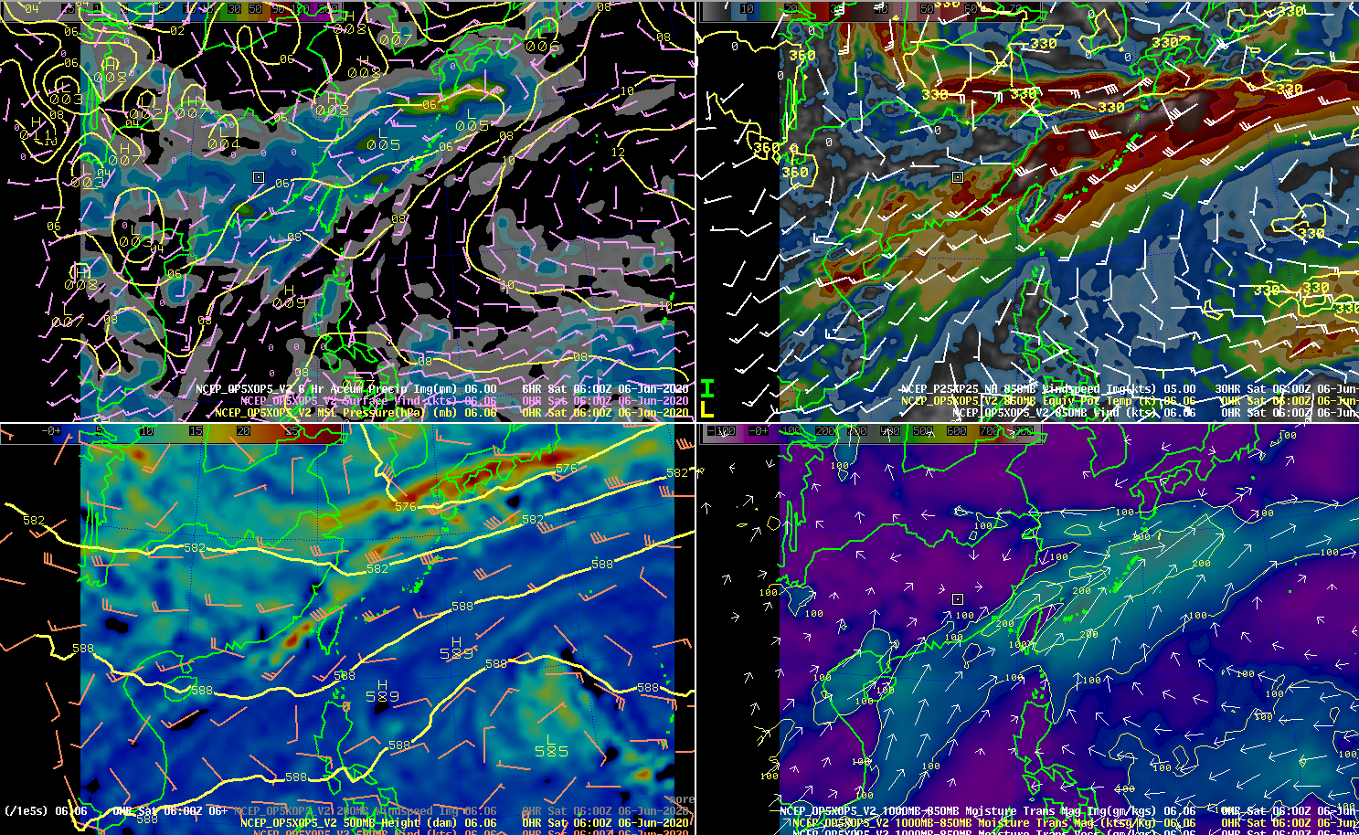

Figure 6. Upper row: (left) NCEP mean level sea pressure (contours), 850 hPa wind (barbs) and 6-h accumulated precipitation (shading) valid at 06 UTC 6 June 2020. (right) NCEP 850 wind (barbs), wind speed (shading), and equivalent potential temperature (contours) valid at 06 UTC 6 June 2020. Lower row: (left) NCEP 500 hPa wind (barbs), height (contours) and vorticity (shading) valid at 06 UTC 6 June 2020. (right) NCEP 1000-850 hPa moisture transport magnitude (shading) and direction (arrows) at 06 UTC 6 June 2020.

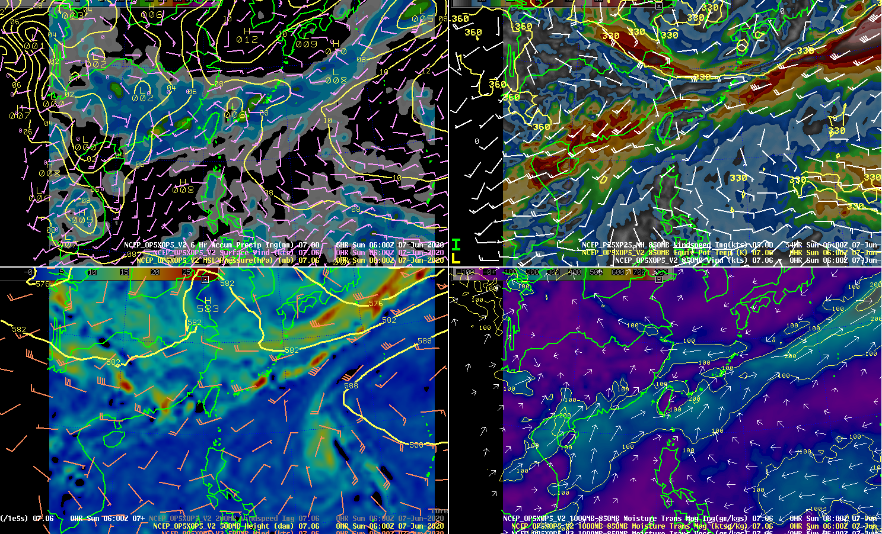

Figure 7. Same as Figure 6, but valid at 06 UTC 7 June 2020.

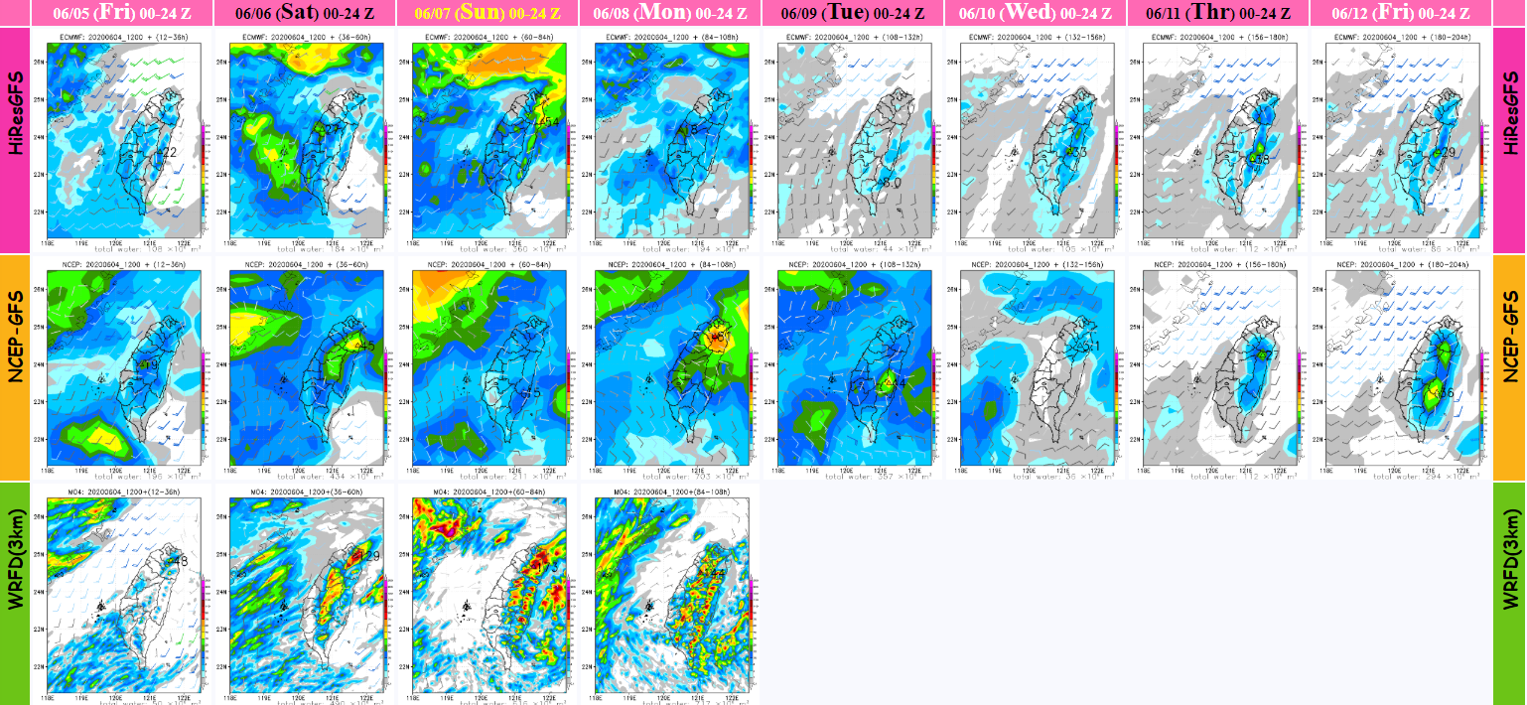

Figure 8. 24-h accumulated rainfall QPFs for the EC model (first row), NCEP model (second row) and the WRFD model (third row) from 5 June 00 UTC to 12 June 00 UTC.

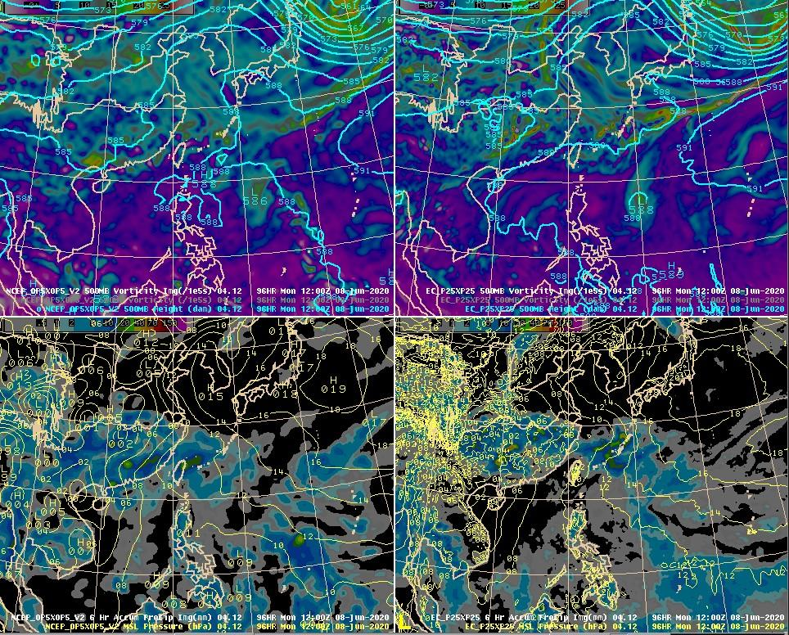

Figure 9. Upper row: (left) NCEP 500 hPa height (contours) and vorticity (shading) valid at 12 UTC 8 June 2020. (right) EC 500 hPa height (contours) and vorticity (shading) valid at 12 UTC 8 June 2020. Lower row: (left) NCEP mean sea level pressure (contours) and 6-h accumulated precipitation (shading) valid at 12 UTC 8 June 2020. (right) EC mean sea level pressure (contours) and 6-h accumulated precipitation (shading) valid at 12 UTC 8 June 2020.

