TAHOPE Weather Discussion (2020-06-09)
Date (UTC): 2020/06/09 2:15
Forecaster: Hsin-hua (CWB)
Author: Frederick Iat-Hin Tam (NTU)

Summary: A mature tropical cyclone, Lekima, is expected to close in on Taiwan in the next 48 hours. While the available models are leaning towards Lekima to miss Taiwan, its associated rainband is still expected to generate strong precipitation over the main TAHOPE domain, especially northern Taiwan. An intensification of southwesterly flow is predicted to cause heavy precipitation in southwestern Taiwan during the extended forecast period.

Day 1 (8 Aug 2019) update:
General Update:
Himawari-8 visible channel satellite imagery (Fig. 1) shows a mature and compact tropical cyclone (“Lekima”) east of Taiwan with well-defined eye and eyewall structures. Coincident surface observations show wind speed of 25 ms⁻¹ around 200 km north of the tropical cyclone. Environment analysis (Fig. 2) shows the cyclone to be located in an area with moderate oceanic tropical cyclone heat potential and low deep layer bulk shear. We therefore anticipate the typhoon to maintain its strength for the next 12-24 hours.

Forecast TC track:
Comparison of EC and NCEP ensemble forecast tracks for Lekima (Fig. 3-4) shows a general agreement for most EC members in predicting Lekima to propagate towards East China Sea and not make landfall directly in Taiwan. There is still some uncertainties for the NCEP, however, with some members still showing landfall in Taiwan over the next few days. The determinative model tracks clearly show differences in terms of Lekima’s distance from Taiwan, with the regional model tracks showing Lekima to be further away from Taiwan than depicted by the global model tracks.

Discussions on Lekima precipitation forecasts:
Most global models are predicting a continuation of Lekima’s northwest movement and we expect the precipitation distributions for the next couple of days to evolve in accordance with Lekima’s location relative to Taiwan.

For Day 1 (8 Aug), model QPF products are placing the precipitation hotspot for the day to the sloped terrain in northern Taiwan. The relative prevalence of precipitation over this general area is due to the forced ascent of the north to northeasterly inflow into Lekima, which will be located to the east of Taiwan for most of Day 1.

For Day 2 (9 Aug), the typhoon will continue to track towards the northwest towards East China Sea, this will change the overall flow direction from northeasterly to northwesterly. Thus, we predict the hotspot will shift from northern Taiwan terrain to the Snow Mountain Range (SMR).

For the extended forecast period, model guidance shows a continued northwestward movement of Lekima (Fig. 7-12). Lekima is forecasted to be closest to Taiwan on 10 Aug. The precipitation for this day will likely be significant, especially in northern Taiwan. As Lekima moves away from Taiwan after 10 Aug, the rainfall in northern Taiwan will likely subside. However, precipitation along the terrain in southwestern Taiwan is expected to become stronger during this period. This precipitation is related to the enhancement of southwesterly monsoon flow by the various tropical cyclone circulations in the WPAC, especially Typhoon Krosa. The evolution of precipitation distributions for this event, as exhibited by the QPF products, is broadly consistent with the above discussions, with a difference being the NCEP model forecasts southwestern Taiwan precipitation to persist through the 12th while the EC model shows a relatively mild day for southwestern Taiwan between the 11th and 12th. In other words, the transition evolution from TC rainfall precipitation to southwest monsoon precipitation is more seamless in the NCEP model, compared to the EC model.

Guidance for decision making:

Day 1:
Confidence | Area and phenomenon | Possible time period | Rainfall estimate
High | A: Forced ascent of TC moist inflow over SMR | 00:00-24:00 | 150-350mm

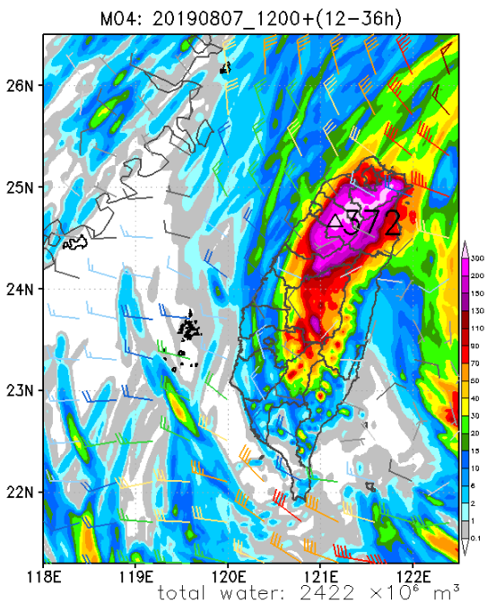

A

Day 2:
Confidence | Area and phenomenon | Possible time period | Rainfall estimate
High | A: Terrain uplifting of TC cyclonic inflow | 00:00-24:00 | 150-350mm
High | B: Terrain uplifting of incoming southwesterly flow | 6:00-24:00 | 150-350mm

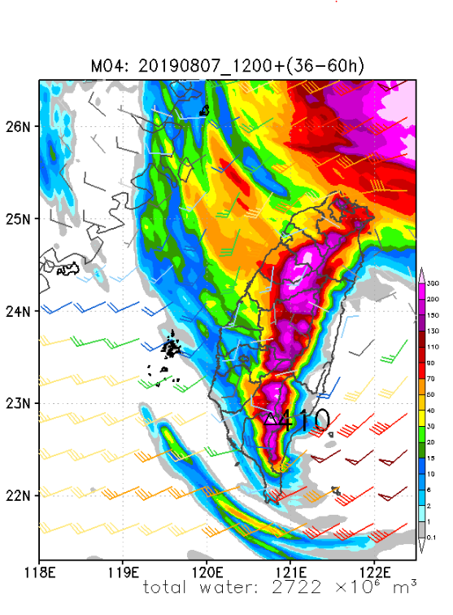

A

B

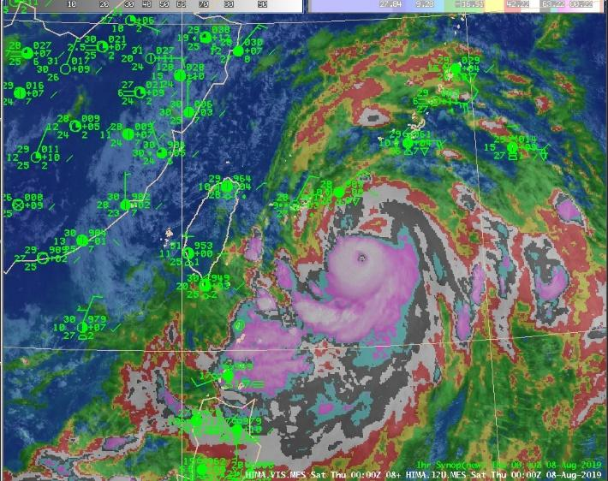

Figure 1. Himawari-8 channel imagery (shading) and surface observations valid at 00 UTC 8 August 2019.

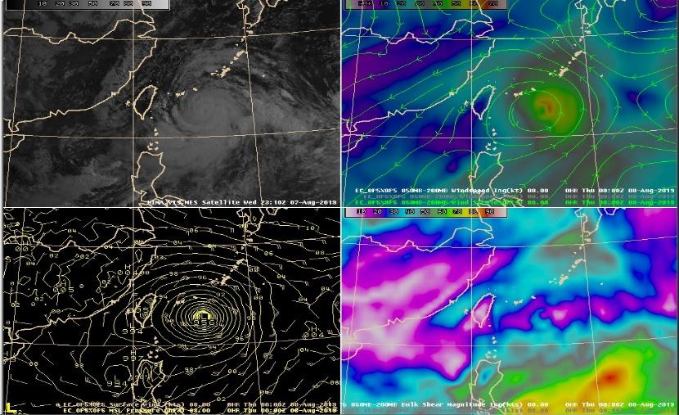

Figure 2. Upper row: (left) Himawari-8 satellite imagery at 2310 UTC 7 August 2019. (right) EC 850-200 hPa windspeed (shading) and direction (streamlines) valid at 00 UTC 8 August 2020. Lower row: (left) EC surface wind (barbs) and mean sea level pressure (contours) valid at 00 UTC 8 August 2019. (right) EC 850-200 hPa bulk shear magnitude (shading) valid at 00 UTC 8 August 2019.

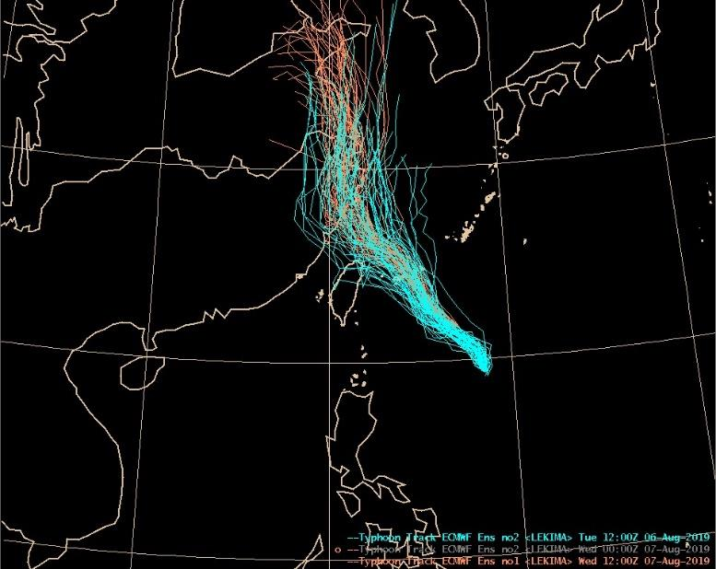

Figure 3. Comparisons for ensemble tracks for Typhoon Lekima. Blue lines are for the EC run initialized at 12 UTC 6 August 2019, whereas brown lines are for the EC run initialized at 12 UTC 7 August 2019.

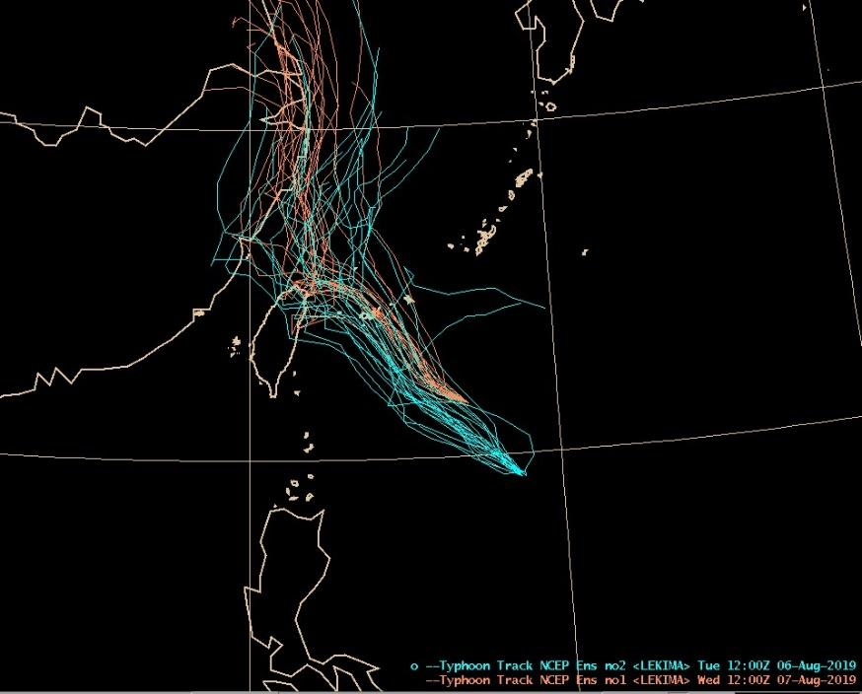

Figure 4. Comparisons for ensemble tracks for Typhoon Lekima. Blue lines are for the NCEP run initialized at 12 UTC 6 August 2019, whereas brown lines are for the NCEP run initialized at 12 UTC 7 August 2019.

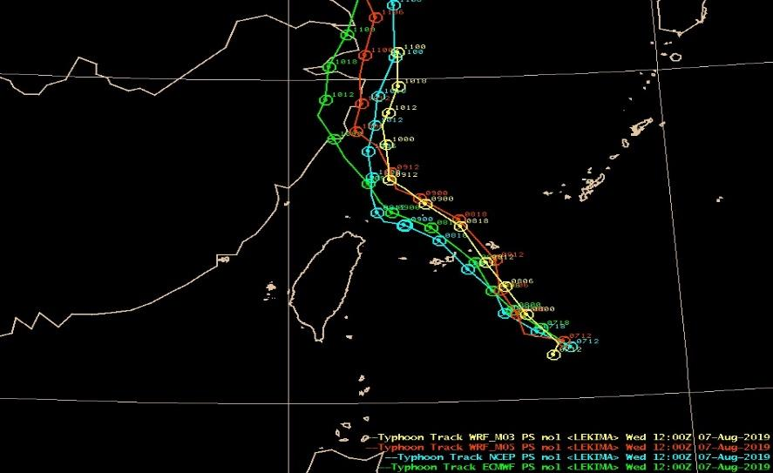

Figure 5. Deterministic tracks of Typhoon Lekima by different models. Yellow and brown lines represent the regional WRF models, whereas blue and green line represent the global NCEP and EC model, respectively.

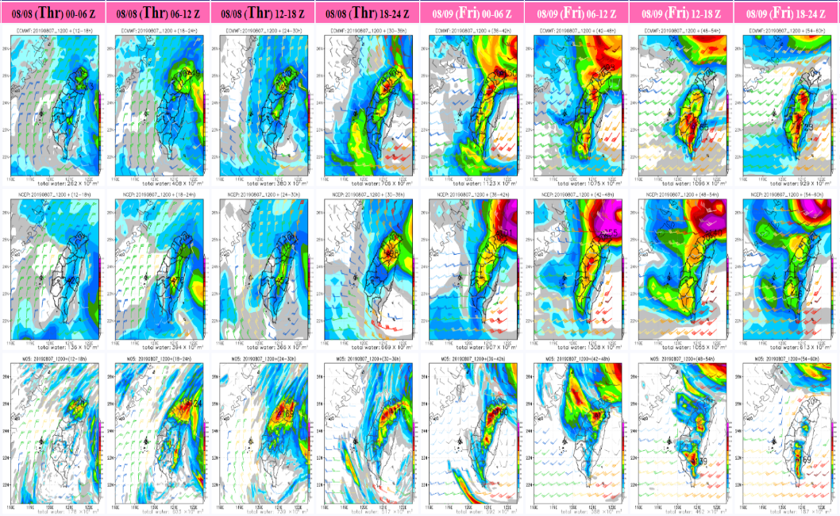

Figure 6. 6-h accumulated rainfall QPFs for the EC model (first row), NCEP model (second row) and the TWRF model (third row) from 8 August 00 UTC to 9 August 24 UTC.

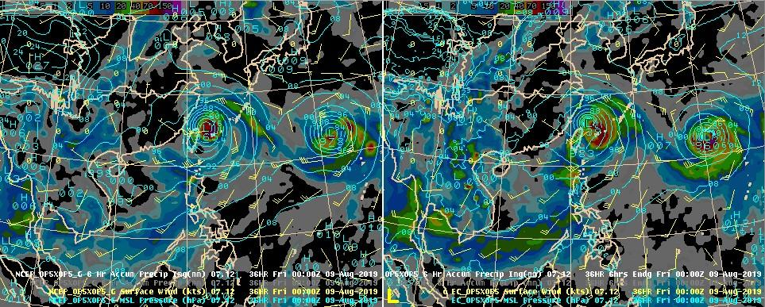

Figure 7. (left) NCEP mean sea level pressure (contours), surface wind field (barbs) and 6-h accumulated precipitation valid at 00 UTC 9 August 2019. (right) EC mean sea level pressure (contours), surface wind field (barbs) and 6-h accumulated precipitation valid at 00 UTC 9 August 2019.

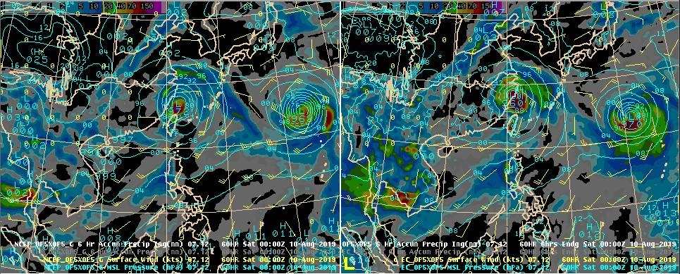
Figure 8. Same as Figure 7, but valid at 00 UTC 10 August 2019.

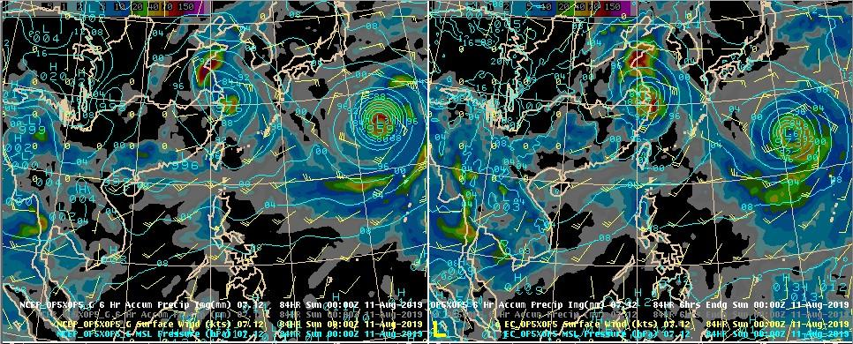
Figure 9. Same as Figure 7, but valid at 00 UTC 11 August 2019.

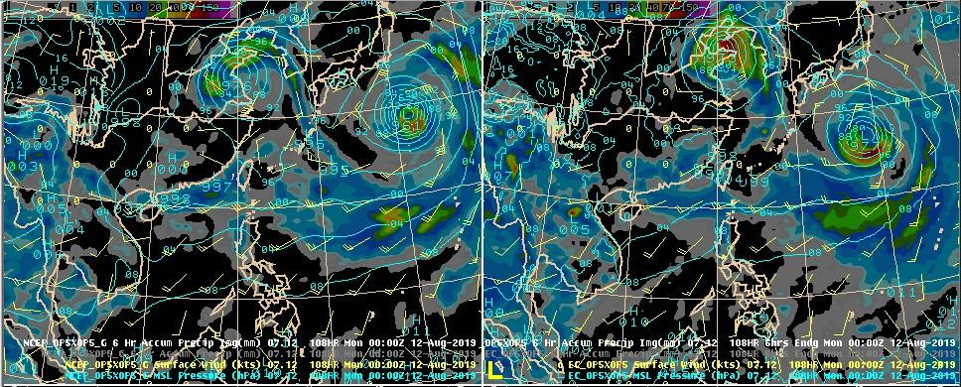
Figure 10. Same as Figure 7, but valid at 00 UTC 12 August 2019.

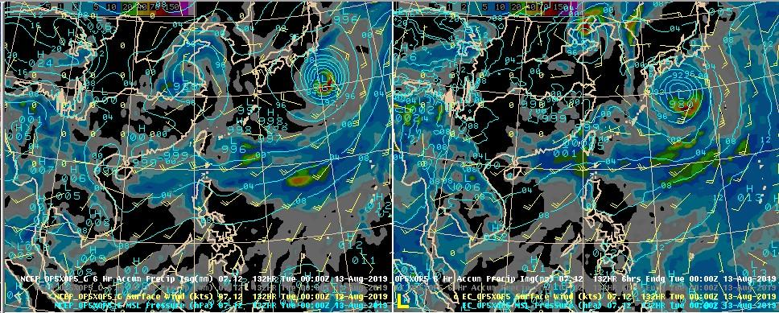
Figure 11. Same as Figure 7, but valid at 00 UTC 13 August 2019.

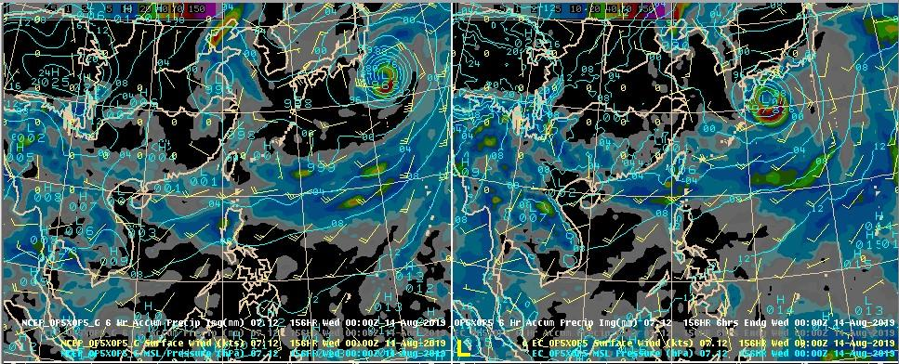
Figure 12. Same as Figure 7, but valid at 00 UTC 14 August 2019.

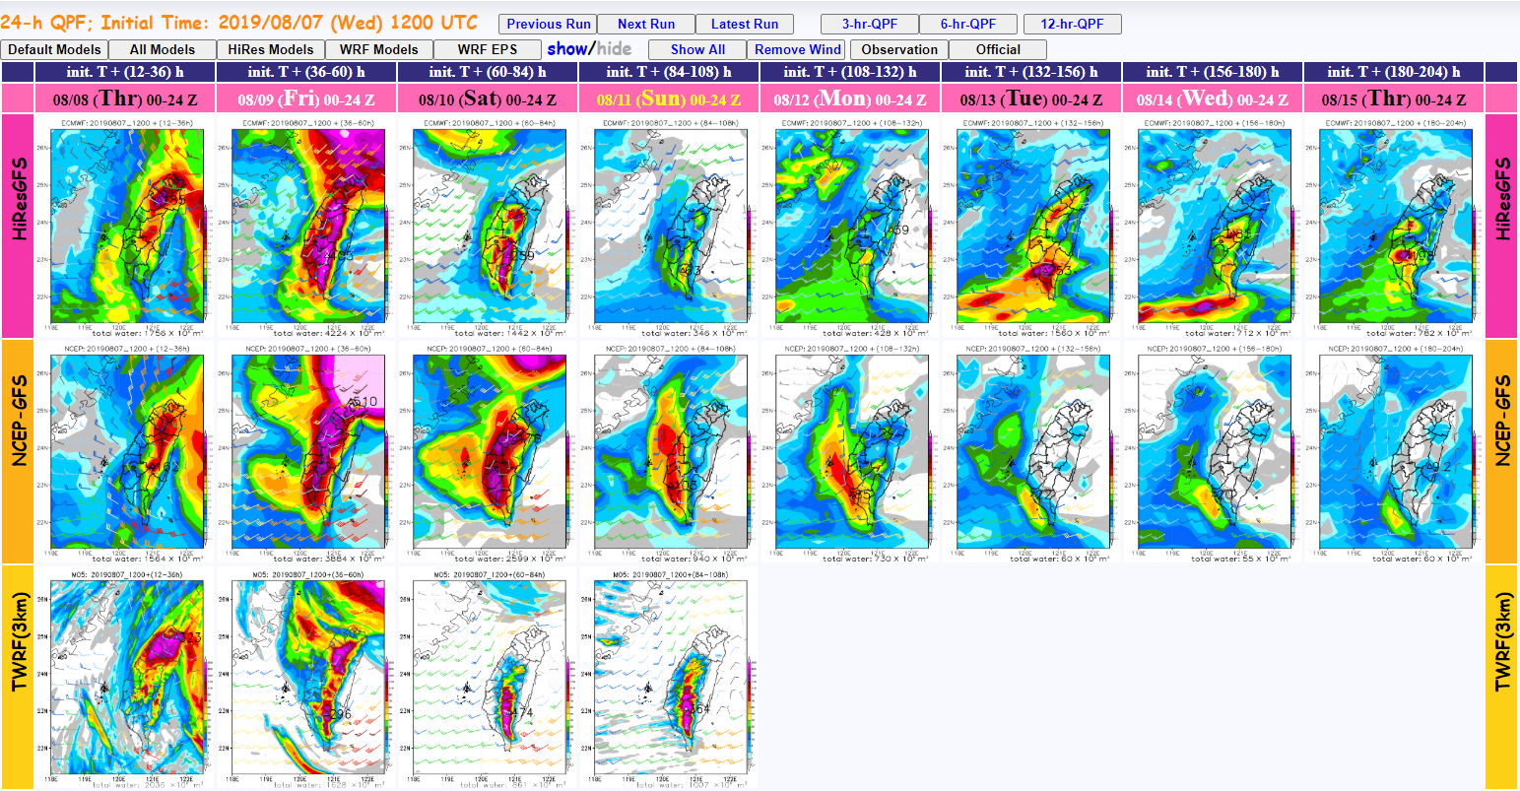

Figure 13. 24-h accumulated rainfall QPFs for the EC model (first row), NCEP model (second row) and the TWRF model (third row) from 8 August 00 UTC to 15 August 00 UTC.

