TAHOPE Weather Discussion (2020-06-10)
Date (UTC): 2020/06/10 2:15
Forecaster: Chieh-Jen (CWB)
Author: Frederick Iat-Hin Tam (NTU)

Debrief on the previous day’s (8 Aug 2019) precipitation forecast: Quantitative Precipitation Estimation (QPE) product for the 24-h accumulated rainfall on 8 Aug 2019 (Fig. 1) shows heavy precipitation along the mountainous terrain of northern Taiwan. The formation of this heavy rainfall area is related to the forced ascent of the north to northwesterly incoming moist air flow associated with Typhoon Lekima. Discrete rainy areas could also be found in the mountainous terrain in central and southern Taiwan. They are more discrete and with lower rainfall accumulation, however. Apart from NCEP, which incorrectly placed the strongest rainfall location in central Taiwan, all other models seemed to be reasonably accurate in depicting the overall rainfall area distribution during 8 Aug. However, most regional models overpredicted the rainfall intensity, despite predicting the rain distribution in an accurate manner. All models missed the moderate precipitation bands offshore of northwestern Taiwan.

Forecast summary: Typhoon Lekima is expected to continue its northwest movement and is currently not expected to directly impact the TAHOPE research domain. Nevertheless, precipitation associated the Lekima’s outer rainband is expected to generate some hefty rainfall along sloped terrain in northern Taiwan for the next 48 hours. The precipitation hotspot is expected to shift to southwestern Taiwan as southwesterly flow takes precedence over Lekima in generating precipitation in the TAHOPE domain.

Day 1 (20 May) update:
Current condition of Typhoon Lekima:
Since Typhoon Lekima has entered an area that is observable with the radar network at and near Taiwan, we will use the radar observations to showcase critical features of the typhoon. 0.5º reflectivity and radial velocity plot (Fig. 2) shows that the typhoon has developed clear concentric eyewall structure. Coloured IR and visible satellite imageries (Fig. 2) indicate relatively warm cloud top temperature between the eyewall, which is consistent with MOAT. The commencement of eyewall replacement cycle is consistent with a slight weakening tendency compared to while the typhoon was still in the Philippines Sea and the eastern sea of Taiwan. Environment analysis (Fig. 3) shows the typhoon to be located in an area with relatively low deep layer shear and oceanic tropical cyclone heat potential northeast of Taiwan. The typhoon is still located in a broad low pressure area, with the predominant steering flow direction being the northwest.

Typhoon Track Guidance:
A summation of the above discussions suggest the typhoon will continue to track towards eastern China slowly and weaken gradually. A comparison of model track guidance (Fig. 4) for this typhoon shows consistency in the timing and location of the landfall, with all models showing the typhoon to make landfall in southern Zhejiang Province, China in the early morning of 10 Aug. While the typhoon is not expected to directly impact Taiwan, we should nevertheless expect some gale and precipitation owing to the typhoon’s rather large wind radius.

Discussion on the impact of Typhoon Lekima to the TAHOPE domain:
Figure 5 shows the 6-h QPF products for 4 different models. All models are showing the northern Taiwan to be the first areas to be impacted by Lekima. Starting from the noon of Aug 8, forced ascent of north-to-northeasterly flow related to Lekima’s inflow and terrain should initiate relatively strong precipitation along the windward terrains in northern Taiwan. The precipitation hotspot at the morning of 9 Aug should shift to the Snow Mountain Range (SMR) as the typhoon location shifted to northeast of Taiwan, which should add a westerly component to the upstream flow of the TAHOPE research domain. Starting from the noon of 9 Aug, southwesterly monsoon flow enhanced by the broad cyclonic circulation in WPAC should start to generate some precipitation along the sloped terrain in southwestern Taiwan. 24-h QPF products for extend forecast period (Fig. 6) further indicate the 9th to be the day when the precipitation for northern Taiwan is strongest and the precipitation hotspots should gradually shift to the southwest terrains during the extend forecast period. Regional model QPFs indicate this monsoon rainfall to have the potential to exceed the typhoon rainband rainfall in northern Taiwan on the 9th. Examination of the surface wind field and low-level moisture transport for 12 Aug and 14 Aug (Fig. 7-8) indicates that this southwesterly flow is partially sustained by the broad circulation of Typhoon Krosa.

Guidance for decision making:

Day 1:
Confidence | Area and phenomenon | Possible time period | Rainfall estimate
High | A: Windward precipitation along SMR | 6:00-22:00 | 100-230mm
High | B: Southwest Monsoon precipitation | 18:00-24:00 | 100-330mm

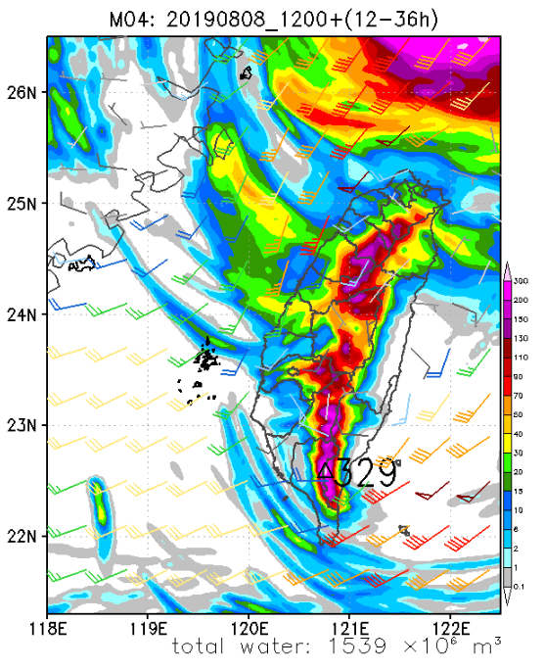

Day 2:
Confidence | Area and phenomenon | Possible time period | Rainfall estimate
High | Southwest Monsoon precipitation | 00:00-24:00 | 100-400mm

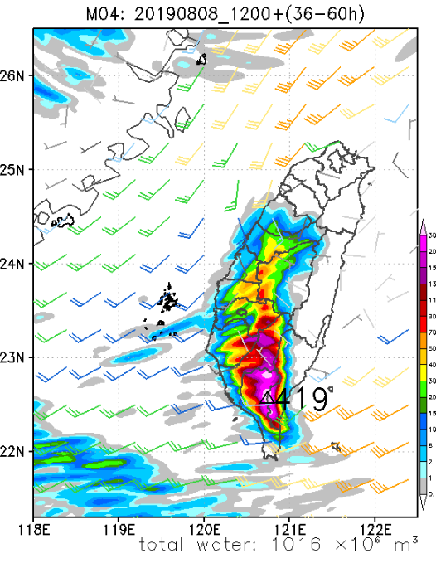

Update and forecasts on the current (10 June 2020 onwards) conditions:
Satellite imagery and NCEP surface wind analysis at 00 UTC (Fig. 9) indicate a developing low pressure system east of the Philippine Islands. Model guidance (Fig. 10-12) is showing this low pressure system to track northwest and impact southern China coasts rather than Taiwan. Thus, the forecast precipitation pattern over Taiwan for the next few days should still be dominated by afternoon thunderstorm in mountainous area, except maybe for southeastern Taiwan during the first half of the weekend (Fig. 13). After the landfall of this low pressure system during the weekend, global models are showing tropical moisture transport to intensify slightly, producing a more favorable environment for more intense afternoon thunderstorm activity early next week.

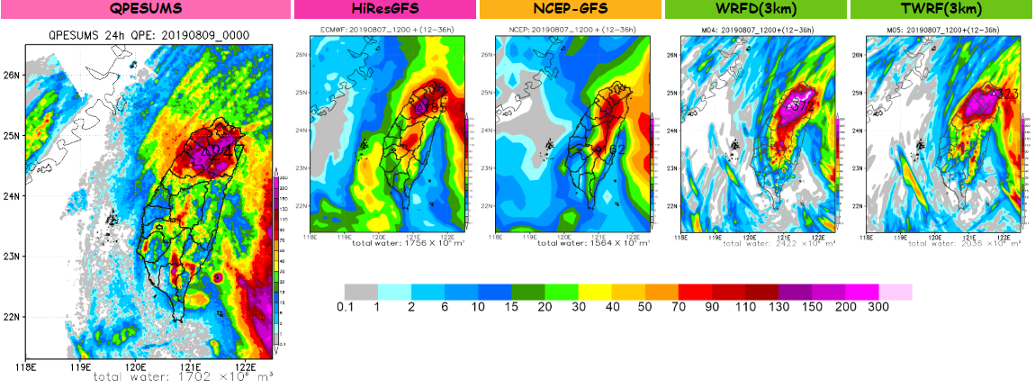
Figure 1. Comparison of 24-h accumulated rainfall QPE and different model QPFs for the 24 h period ending at 00 UTC 9 Aug 2020.

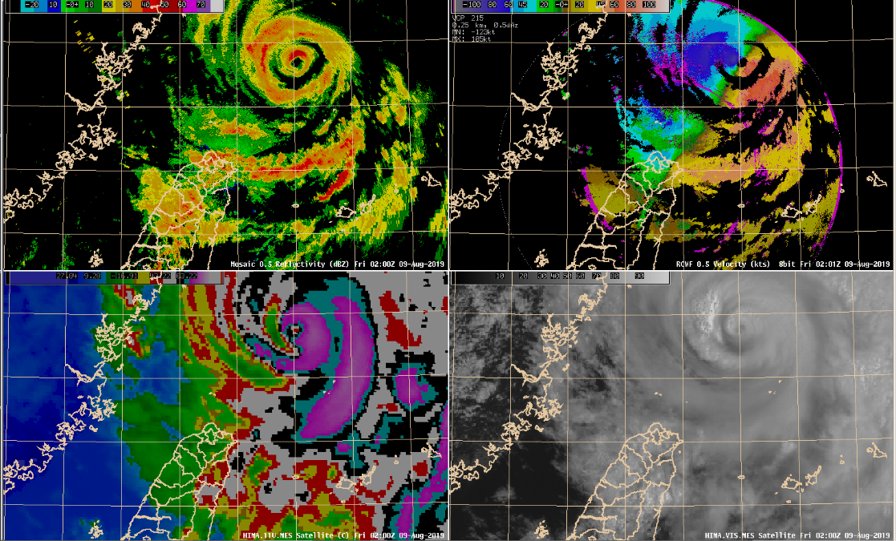

Figure 2. 02 UTC 9 Aug 2019 radar reflectivity (upper left, ul) and radial velocity (upper right, ur) observations at 0.5 degree. The lower two panels are the Himawari-8 coloured IR (lower left, ll) and visible (lower right, lr) at 02 UTC 9 Aug 2019.

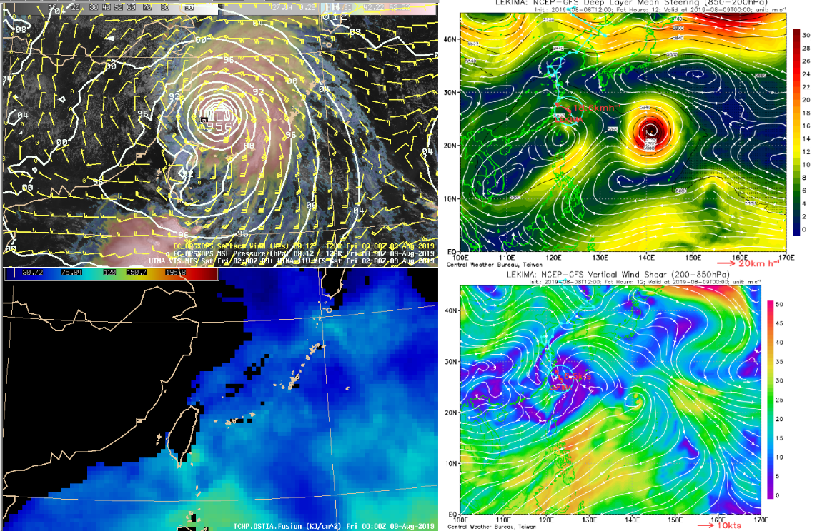

Figure 3. (ul) EC surface wind field (barbs) and mean sea level pressure valid at 00 UTC 9 Aug 2019. Shading is the satellite imagery at 02 UTC 9 Aug 2019. (ur) NCEP 850-200 hPa steering flow pattern (streamline) and wind speed (shading) valid at 00 UTC 9 Aug 2019. (ll) OSTIA TCHP observations at 00 UTC 9 Aug 2019. (lr) NCEP vertical wind shear flow pattern (streamline) and shear intensity (shading) for the layer between 200 and 850 hPa, valid at 00 UTC 9 Aug 2019.

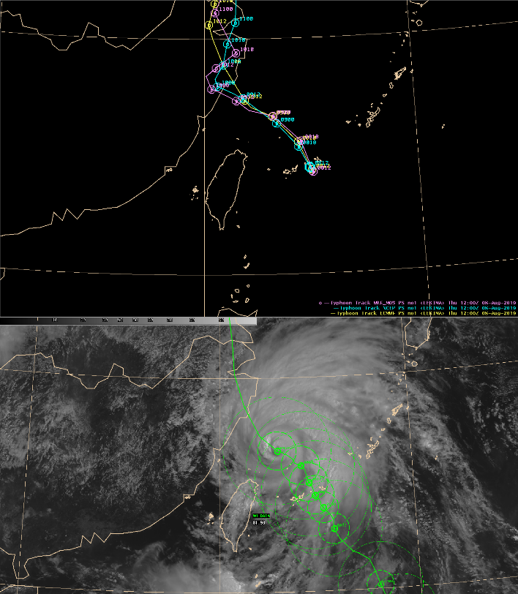

Figure 4. (upper panel) Model guidance for the track of Typhoon Lekima. Purple, cyan, and yellow line represent the TWRF, NCEP and EC model, respectively. (lower panel) CWB best track and wind radius for Lekima and the official CWB forecast track.

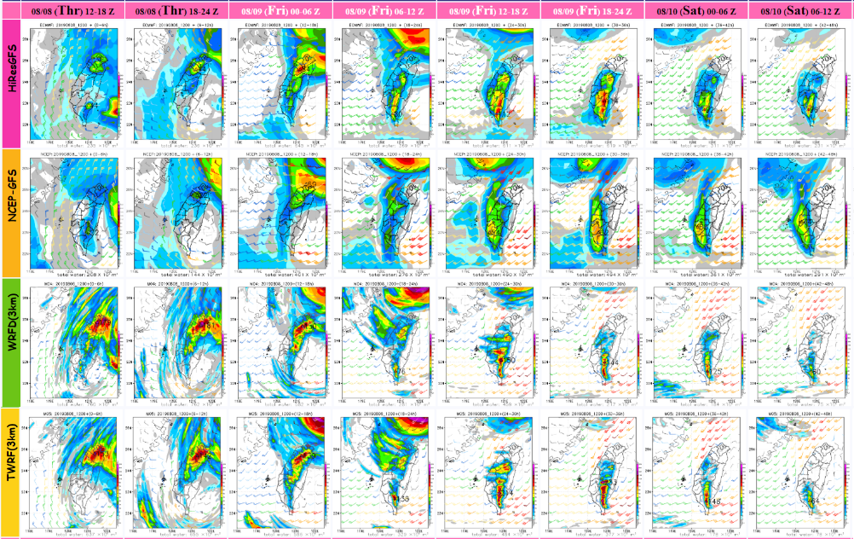

Figure 5. 6-h accumulated precipitation QPFs for EC (first row), NCEP (second row), WRFD (third row) and TWRF (fourth row) models for the period between 8 Aug 2019 12 UTC to 10 Aug 2019 12 UTC.

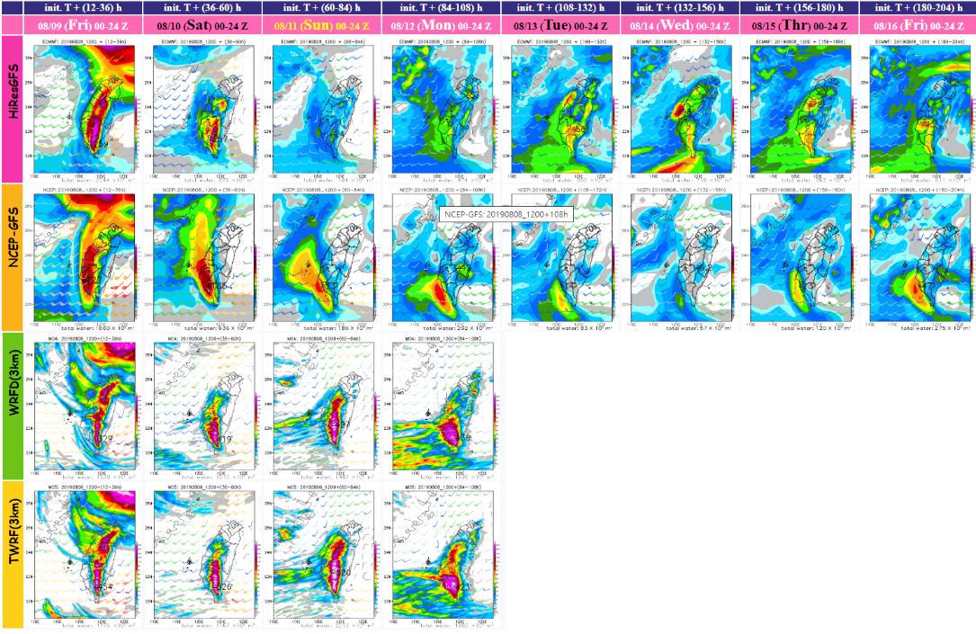

Figure 6. 24-h accumulated precipitation QPFs for EC (first row), NCEP (second row), WRFD (third row) and TWRF (fourth row) models for the period between 9 Aug 2019 00 UTC to 16 Aug 2019 24 UTC.

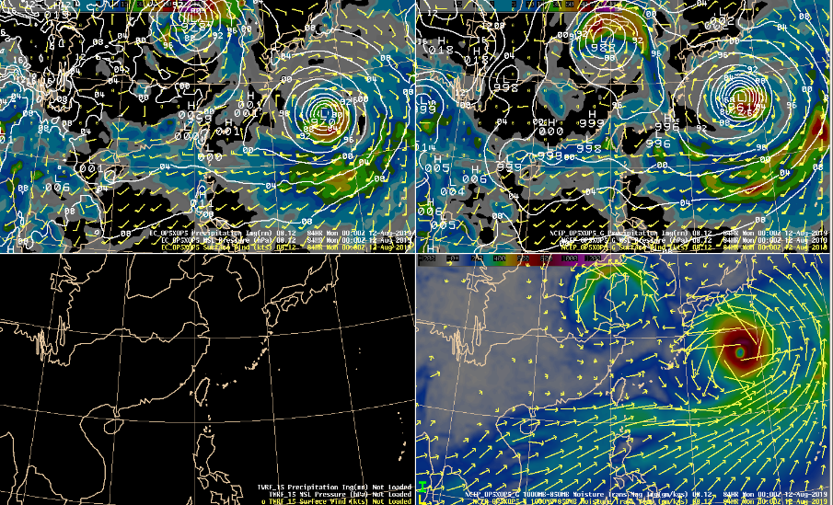

Figure 7. (ul) EC surface wind field (barbs), mean sea level pressure, and precipitation (shading) valid at 00 UTC 12 Aug 2019. (ur) NCEP surface wind field (barbs), mean sea level pressure, and precipitation (shading) valid at 00 UTC 12 Aug 2019. (ll) NCEP 1000-850 hPa moisture transport (shading) and moisture transport direction (arrows) valid at 00 UTC 12 Aug 2019.

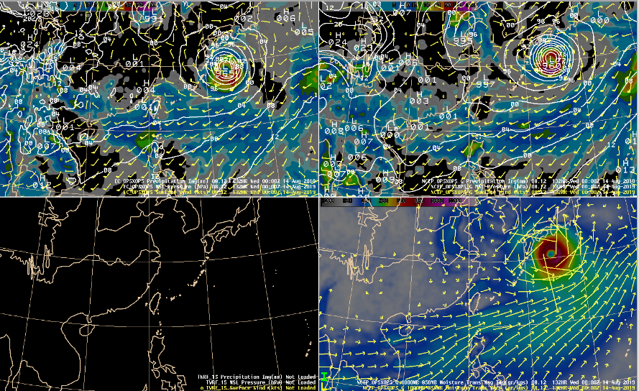

Figure 8. Same as Figure 7, but valid at 00 UTC 14 Aug 2019.

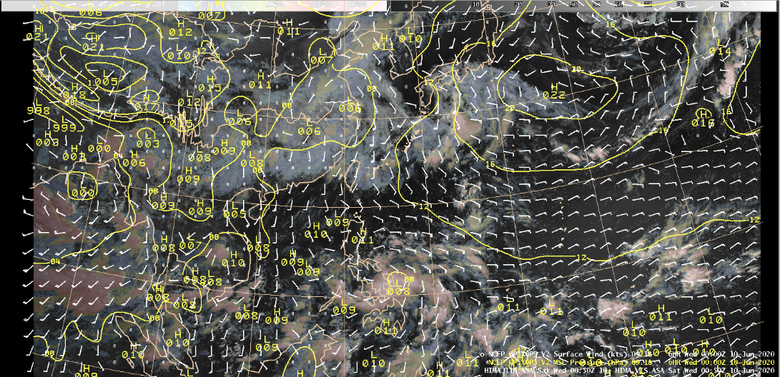

Figure 9. 0050 UTC 10 June 2020 Himawari-8 satellite imagery (shading), NCEP surface wind (barbs) and mean sea level pressure (contours) analysis valid at 00 UTC 10 June 2020.

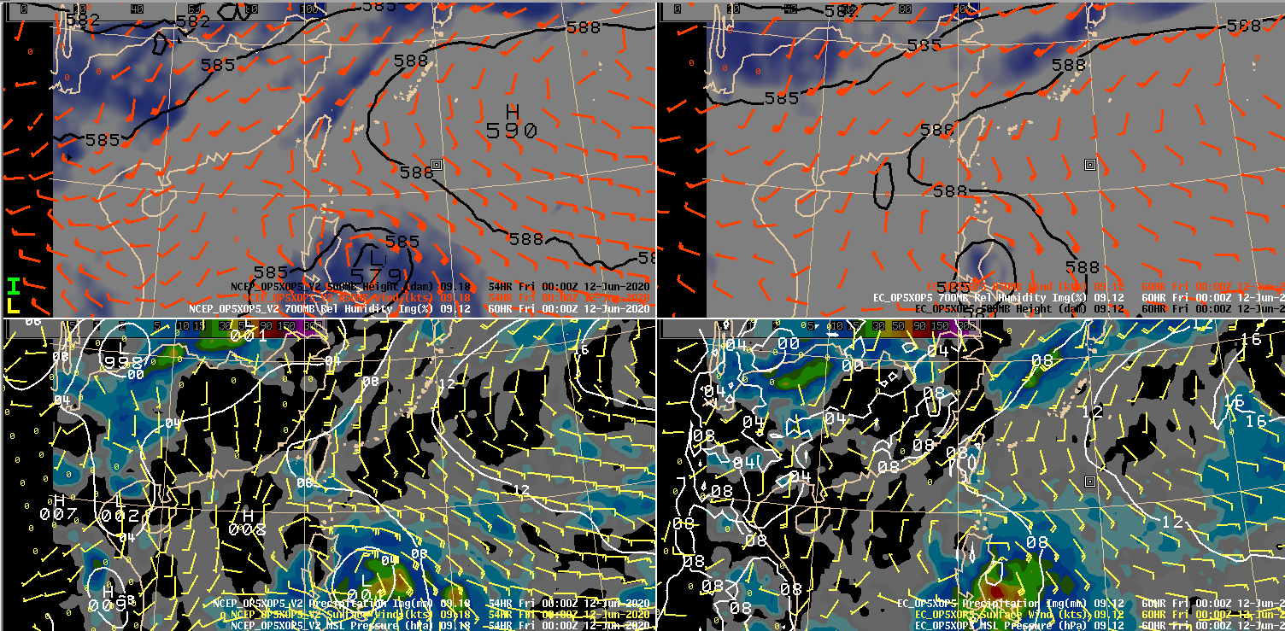

Figure 10. (ul) NCEP 850 hPa wind (barbs), 500 hPa height (contours), and 700 hPa relative humidity (shading) valid at 00 UTC 12 Aug 2019. (ur) EC 850 hPa wind (barbs), 500 hPa height (contours), and 700 hPa relative humidity (shading) valid at 00 UTC 12 Aug 2019. (lr) NCEP surface field (barbs), mean sea level pressure (contours) and precipitation (shading) valid at 00 UTC 12 Aug 2019. (ll) EC surface field (barbs), mean sea level pressure (contours) and precipitation (shading) valid at 00 UTC 12 Aug 2019.

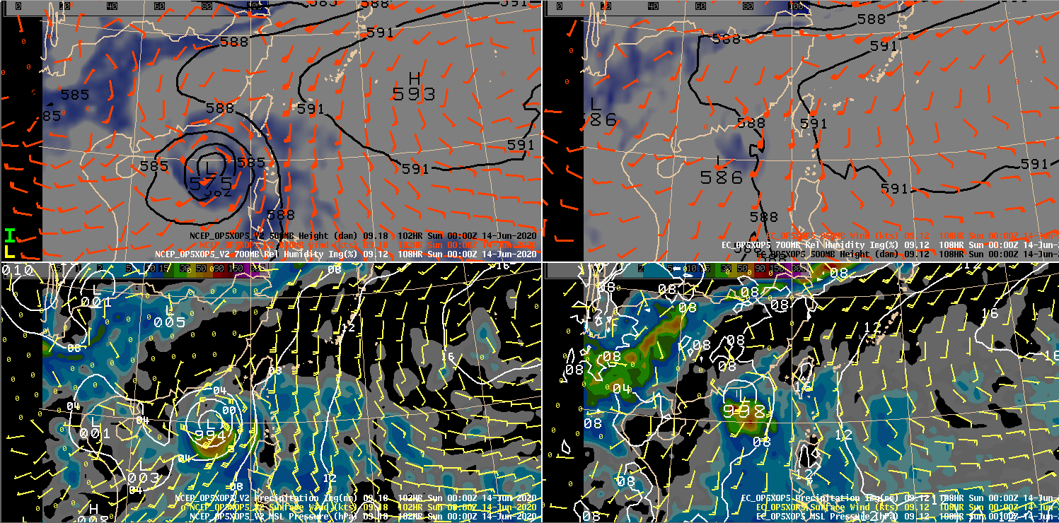

Figure 11. Same as Figure 11, but valid at 00 UTC 14 June 2020.

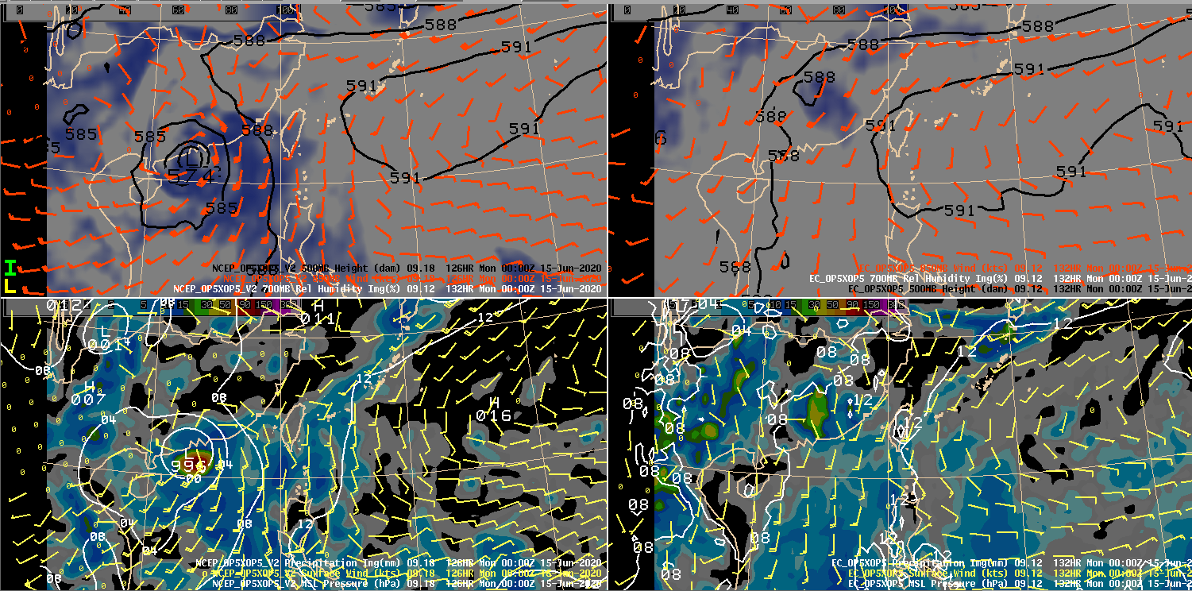

Figure 11. Same as Figure 11, but valid at 00 UTC 15 June 2020.

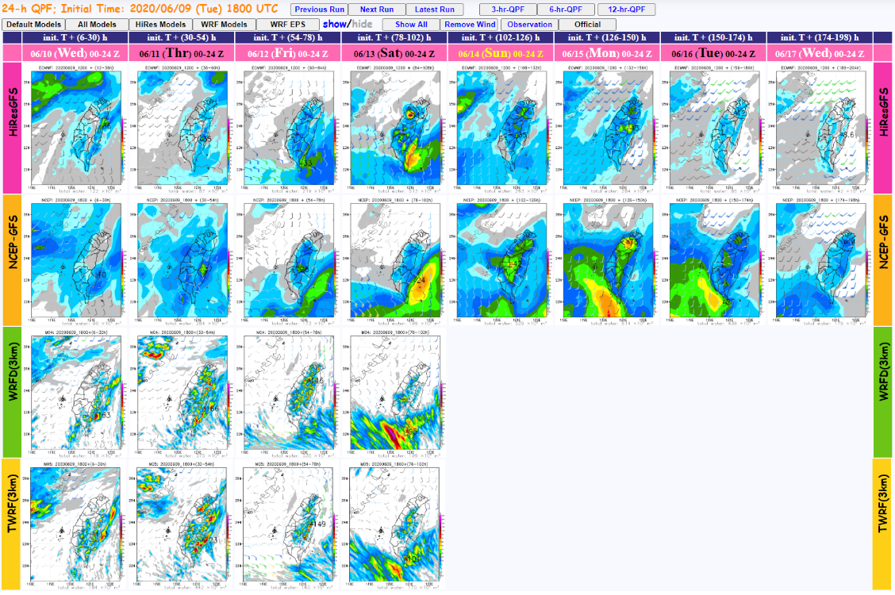

Figure 13. 24-h accumulated precipitation QPFs for EC (first row), NCEP (second row), WRFD (third row) and TWRF (fourth row) models for the period between 10 June 2020 00 UTC to 17 June 2020 24 UTC.

