TAHOPE Weather Summary (08/09~08/13)
Date (UTC): 2022/08/09
Author (in alphabetical order): Shian-Rong Liao, Chieh-Hsiang Fan, Hsuan-Cheng Lin
Submitted at (UTC): 2022/08/09 09 UTC

- Analysis of current weather (08/09 00Z)
  - A small amount of rainfall took place in southern Taiwan due to the circulation of 97W. In other regions, almost no precipitation occurred at 0100 UTC. (Figure 1.)
  - Surface weather chart (Figure 2.) shows that Taiwan is located in the western edge of subtropical high, so the subsidence is not too strong. The monsoon trough occupies the entire South China Sea and extends to the Indian Ocean. In this unstable environment, lots of convective cloud systems are triggered by the strong water vapor flux. In addition, the stationary front which has no effect on low latitudes lingers near the Shandong Peninsula and Korea.
  - The sea breezes along the DanShui river and KeeLung river are not obvious at 01 UTC. (Figure 3.) And it is also not expected to be significant at noon because of the southeasterly wind.
  - The Skew-T diagram of Banqiao (Figure 4.) shows significant subsidence structure near 850hPa level caused by subtropical high. And almost from low level to 300mb has easterly wind component.
  - The obvious subsidence and the weak land-sea circulation both influence the development of afternoon thunderstorms in Taipei. Therefore, the score of the afternoon thunderstorm checklist is about 9 to 10. Which suggests that today’s environment is not very good but still supports the development of afternoon thunderstorms in the mountain region in northern Taiwan.

- Tropical disturbance 97W analysis:
- The location of 97W at 08/09 00 UTC (Figure 5.) is in the southeast of Hainan(海南) island. And the surface wind according to ASCAT shows that the strongest wind of its circulation is about 30kts. (Figure 6.)
- From the satellite image of 97W we can see that the low brightness temperature of the convective region has some distance from LLCC which means it still needs time to improve its inner core structure. (Figure 7.)
- Although the sea surface temperature (Figure 8.a) is favorable and the ocean heat content (Figure 8.b) and vertical wind shear (Figure 9) is passable, the large circulation (Figure 10.) due to its characteristics of monsoon low will severely limit its development. So it is predicted to landfall in Guangdong(廣東) or Leizhou(雷州) Peninsula with tropical storm intensity.

- 500 hPa verification (EC & NCEP) (Figure 11.)
- In EC model, the performance of forecast the location of low pressure in north and subtropical high is better than NCEP model.

- Synoptic Condition Forecast (EC) (Figure 12. ~ 16.)
- 8/9~10 The tropical disturbance 97W is located off the southwestern coast of Taiwan and still moves westward. The subtropical high 5880m at 500mb covers northern Taiwan. The moisture around Taiwan at 700 and 850mb is low, the wind from surface to 750mb is mainly southeast wind.
- 8/11-8/12 Subtropical high is around Taiwan and keep the 700 and 850mb moisture still low. Surface wind turns into south wind on 8/12 and the speed is low.
- 8/13 Surface wind turns into southeast wind and the subtropical high is still cover above Taiwan.
- QPF Verification (Figure 17.)
  - In observation data, the rain mainly covered Chiayi and the northeastern mountainous area. The maximum occurred at southwestern mountainous area.
  - WRFD and TWRF neither capture the position of maximum, nor capture the overall actual rainfall area.
  - EC captured the rainfall pattern and the position of maximum very well, but generally underestimated the signal for all area.
  - Although NCEP did not capture the position of maximum, it overall captured the rainfall pattern. In terms of strength of signal, it performed better than EC.

- QPF Forecast (Figure 18.)
  - On August 9-11, although the wind direction is southeast due to the 97W, the rainfall pattern at windward side is not that obvious. This may be because the water vapor flux is not as strong as expected.
Contrary to the windward side, the leeward side have apparent afternoon thunderstorm signal. There may be two reasons to explain this. First, 97W “push away” the subtropical high. Second, the wind speed at leeward side is relatively weak, and land-sea circulation can play an important role.
  - On August 12-13, as the 97W left, subtropical high gradually cover Taiwan, water vapor flux weaken, and the wind direction turn to roughly southwest. The environment is not favorable to precipitation as previous days, and we expected a weaker afternoon thunderstorm signal.

Appendix. Figures

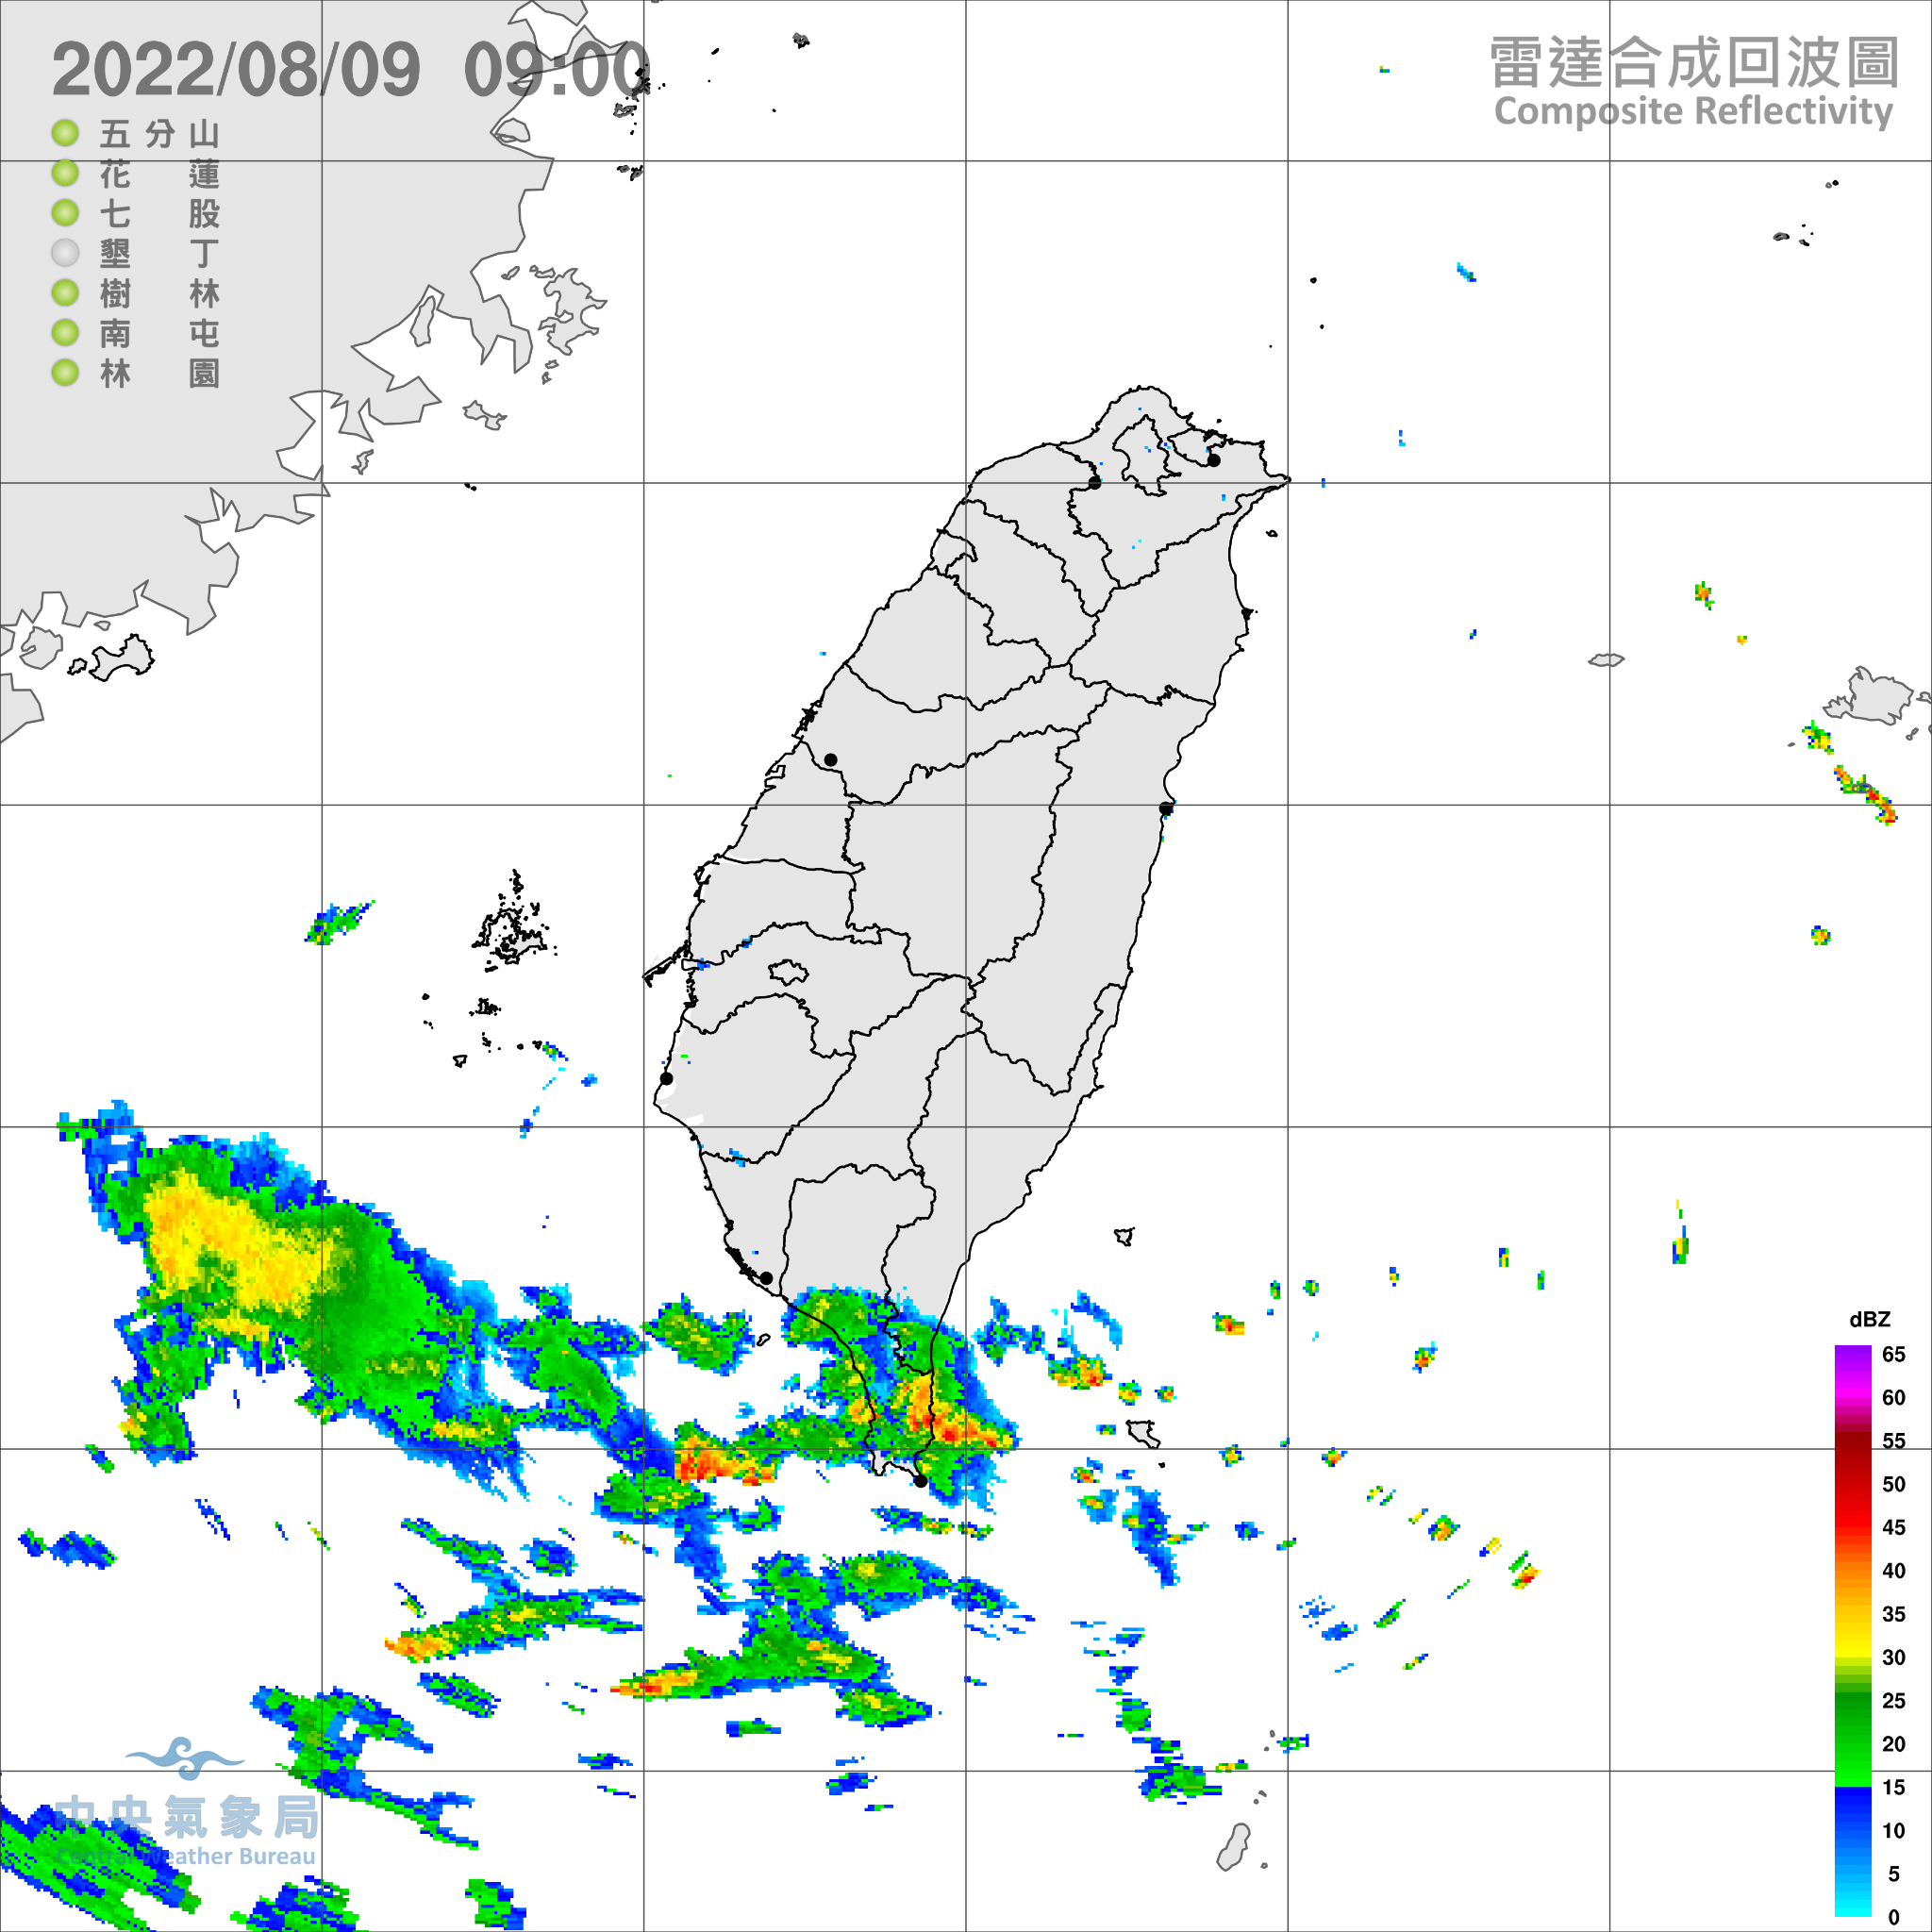
Figure 1. Rader Image of Taiwan at 08/09 01:00 UTC.

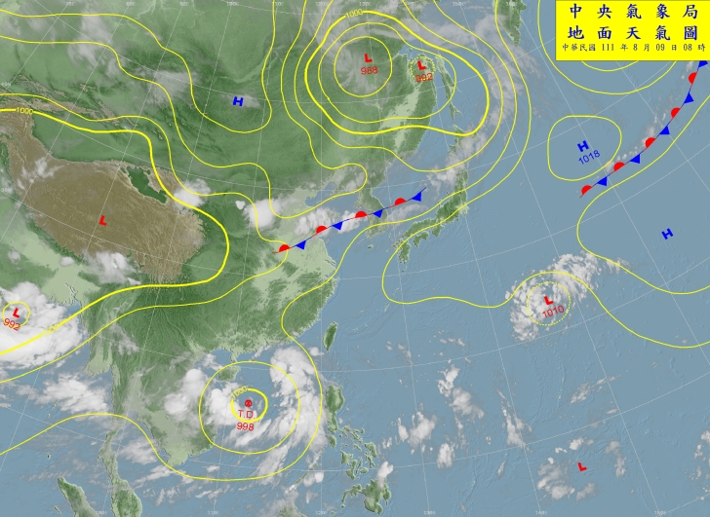
Figure 2. Synoptic surface weather chart of East Asia at 08/09 00 UTC.
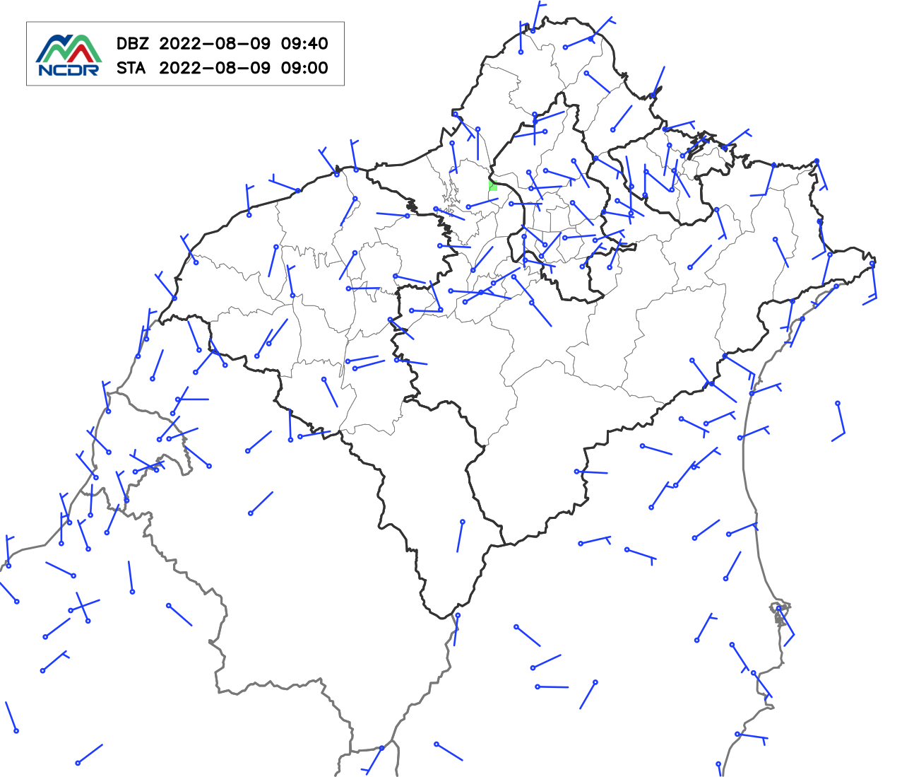
Figure 3. The wind speed and wind direction of northern Taiwan from the observation stations at 08/09 01 UTC.

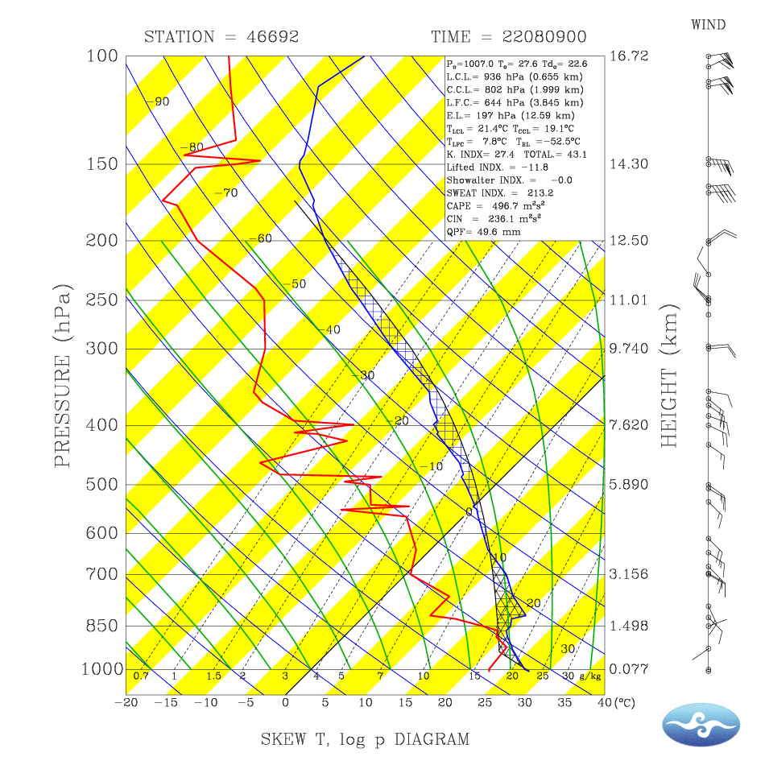
Figure 4. Skew-T Log-P Diagram of Banqiao station at 08/09 00Z.
(a)
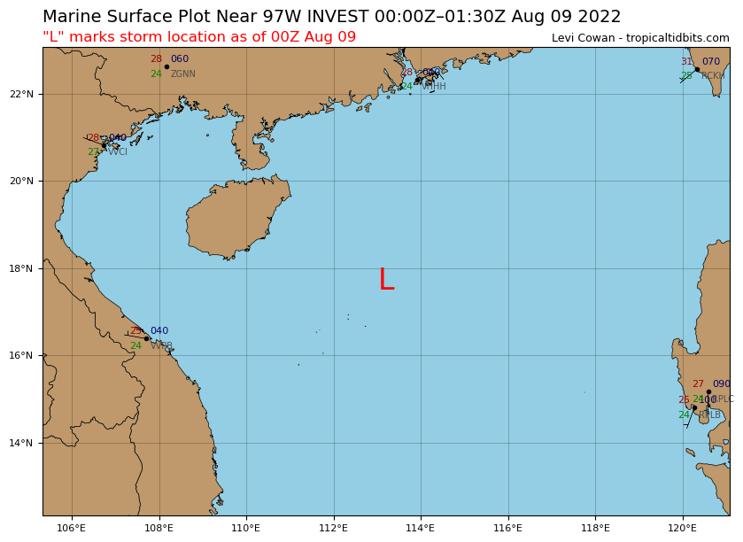
Figure 5. Current (08/09 00 UTC) Location of 97W.

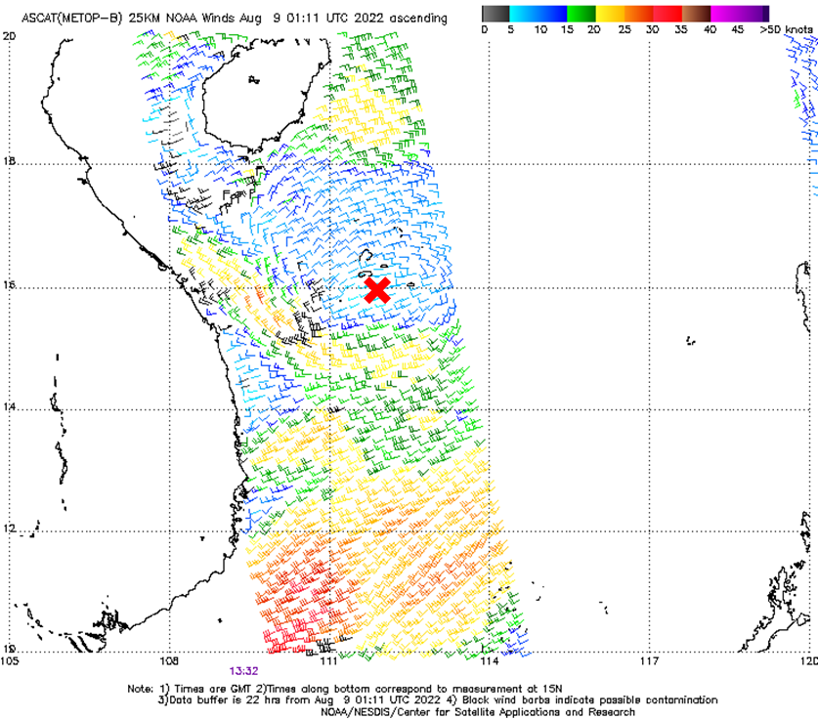
Figure 6. Surface wind field of 97W which is observed by ASCAT at 08/09 01:11 UTC. The X mark is the low level circulation center of 97W.
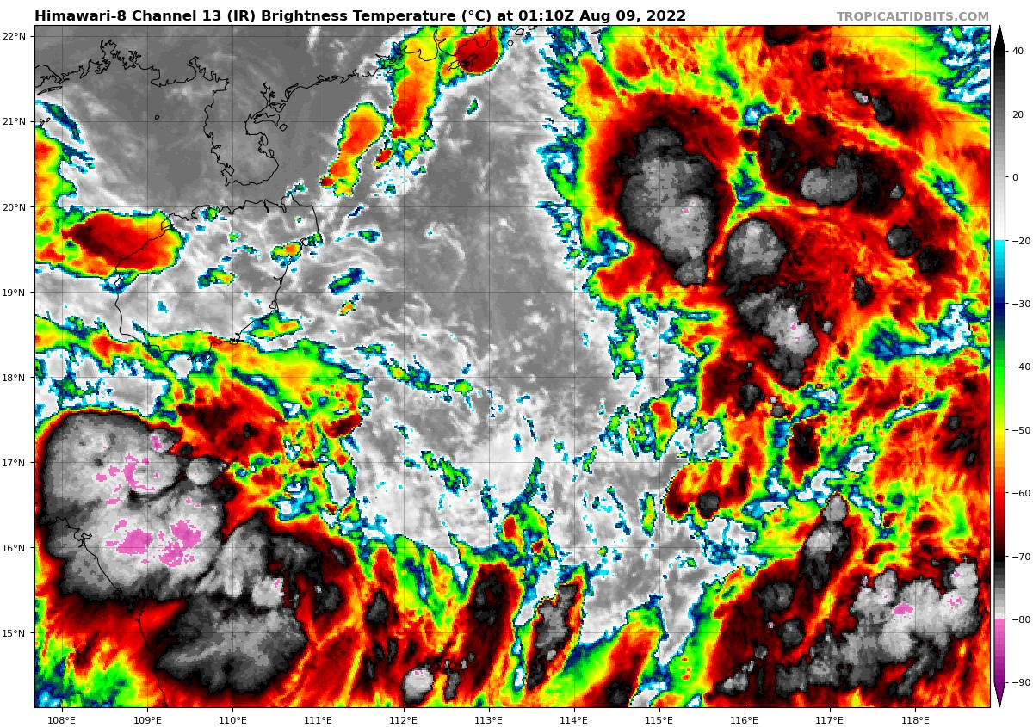
Figure 7. Brightness Temperature of 97W at 08/09 01:10 UTC.

(a)
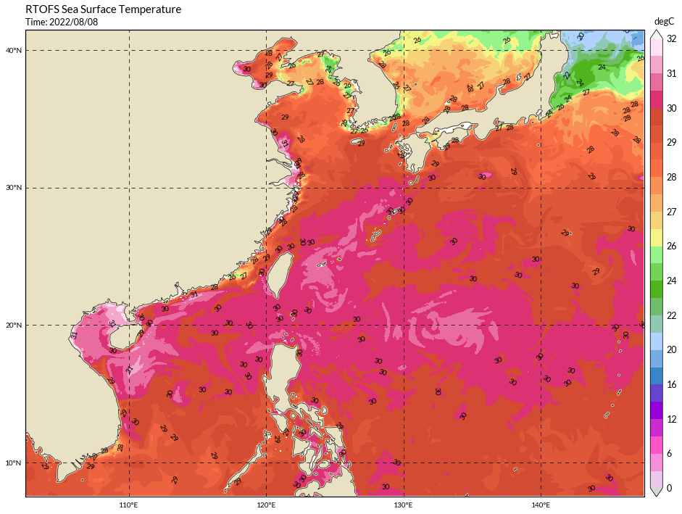
(b)
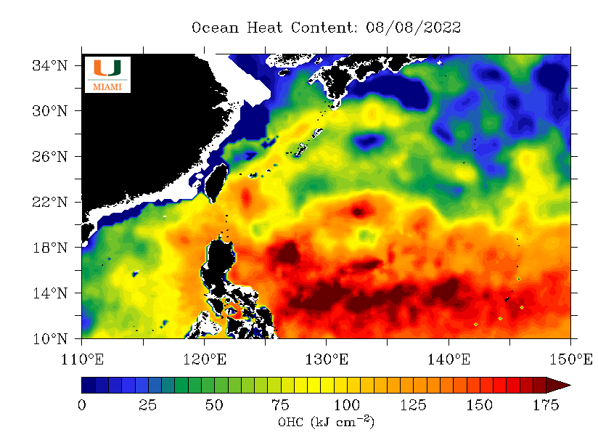
Figure 8. Western Pacific (a)Sea surface temperature on 08/08 and (b)Ocean heat content on 08/08.

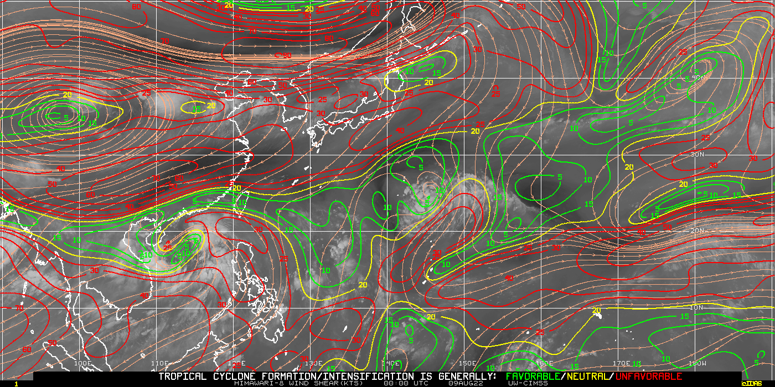
Figure 9. Vertical wind shear magnitude at 08/09 00:00 UTC.

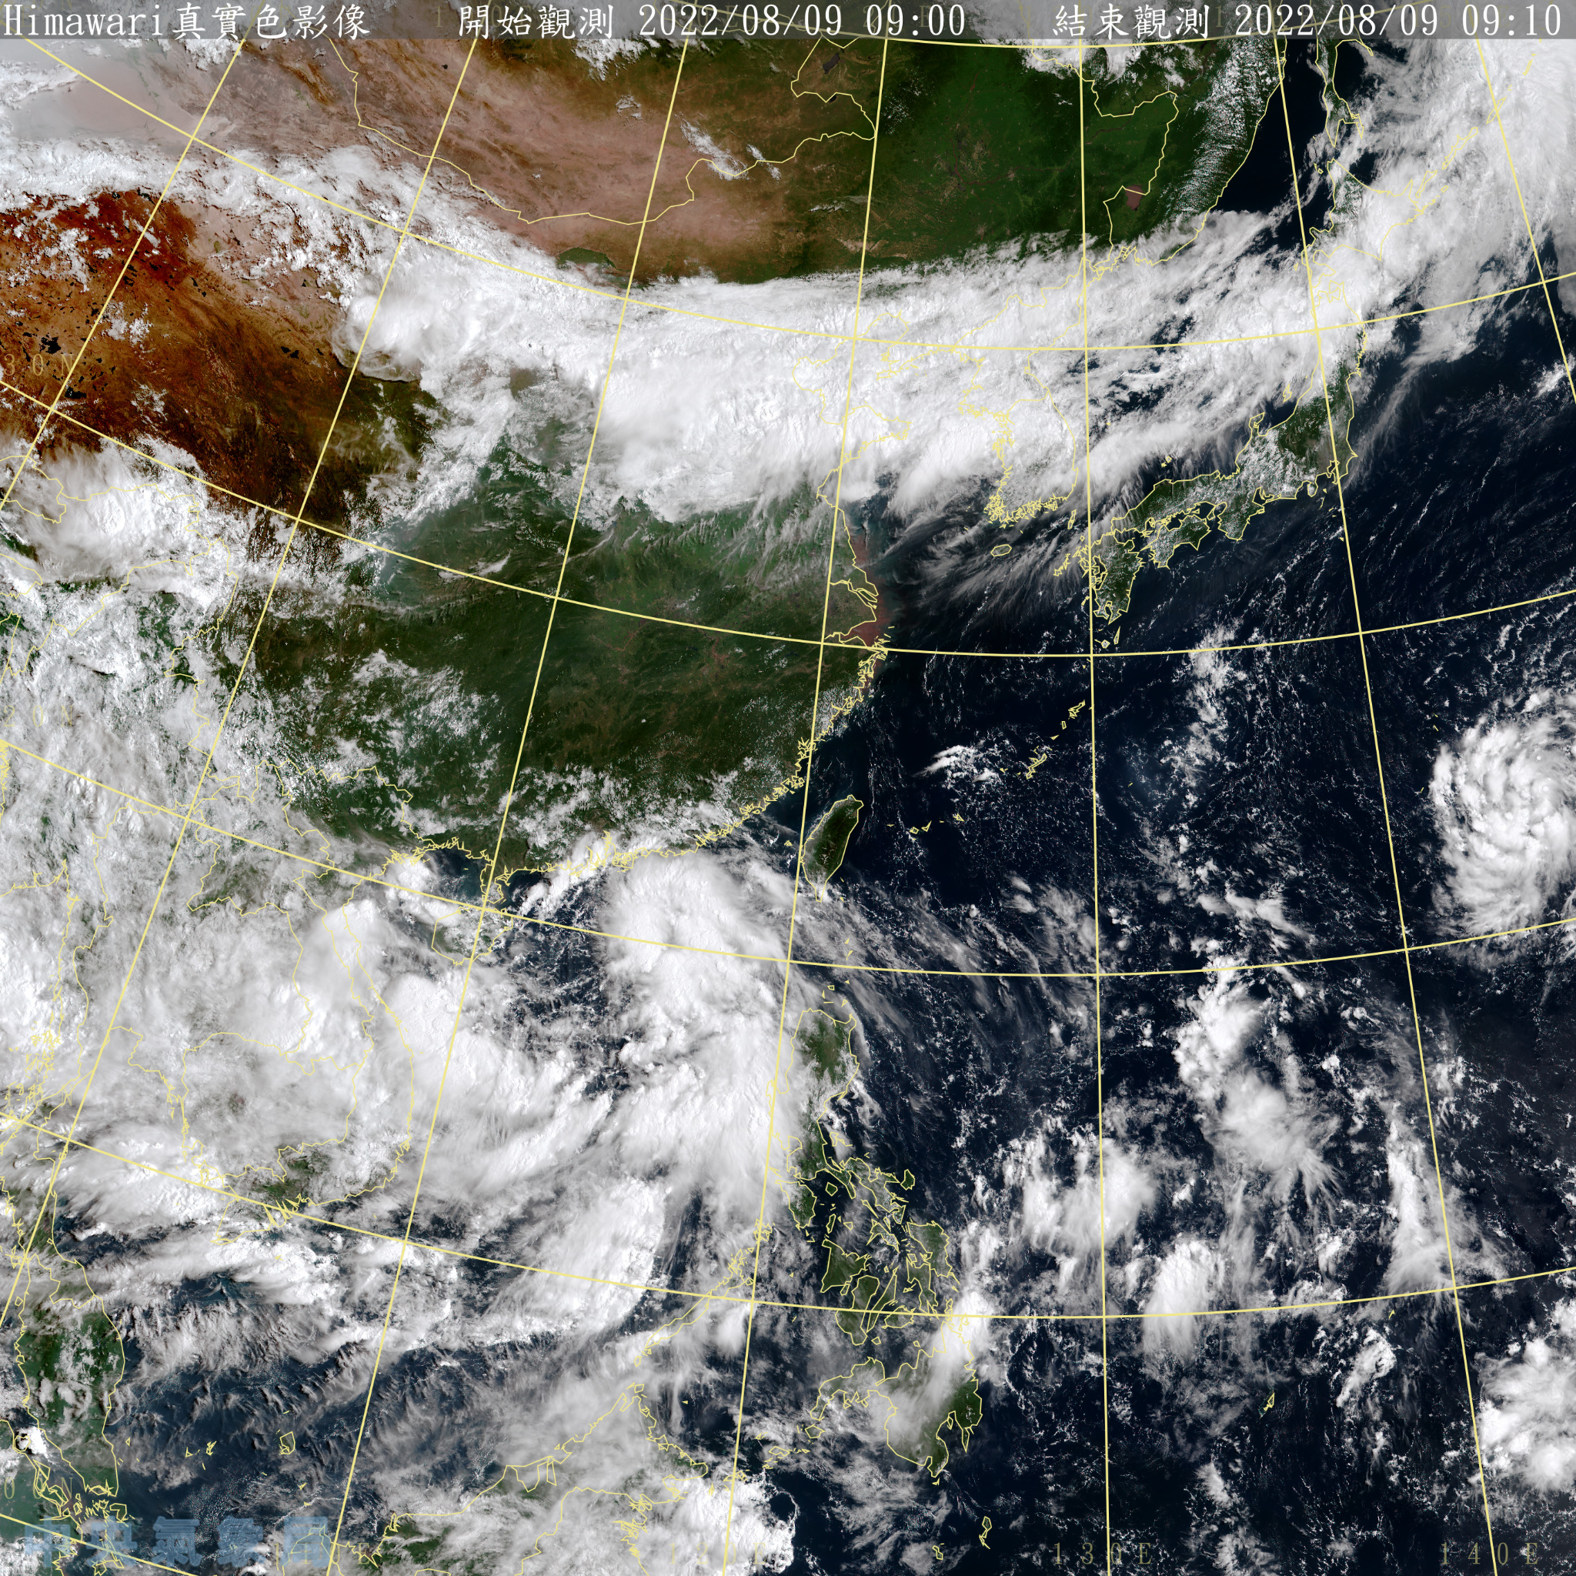
Figure 10. Satellite image of East Asia at 08/09 01 UTC. The large circulation of 97W can be clearly seen in this figure.

(a)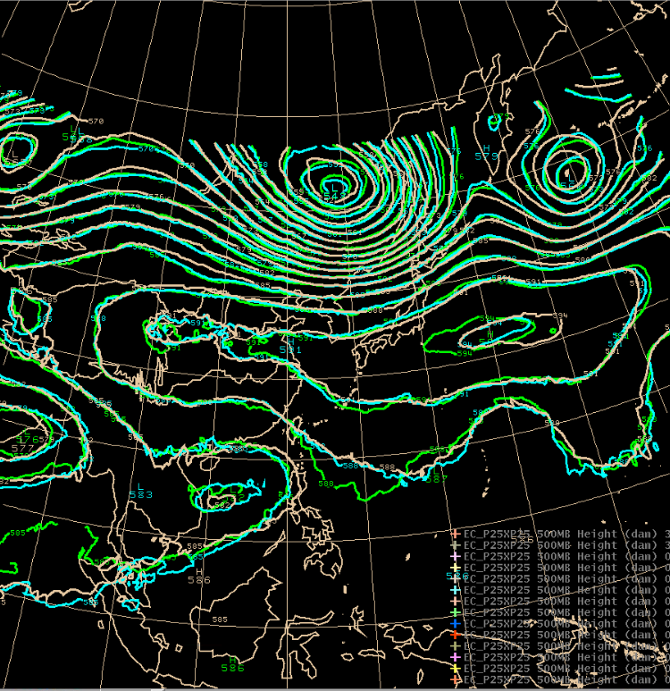(b)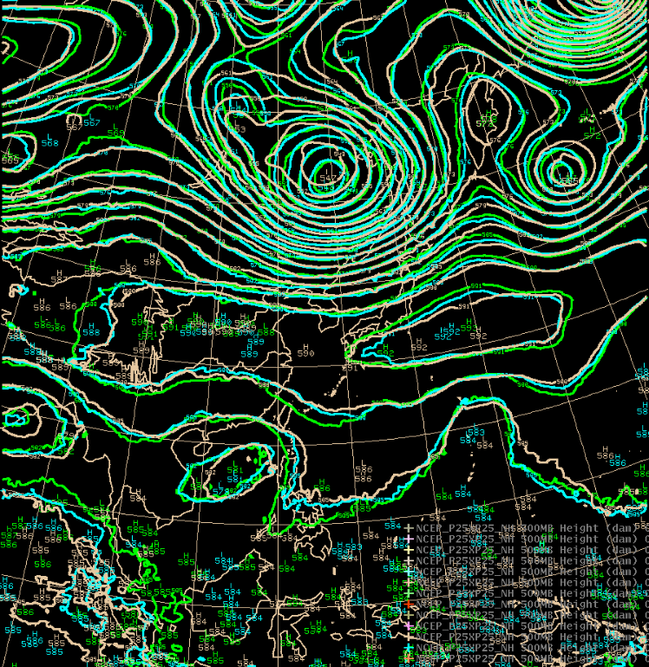

Figure 11. Verifications for forecasts of the 500 hPa height in (a) EC and (b) NCEP models with the reanalysis field.
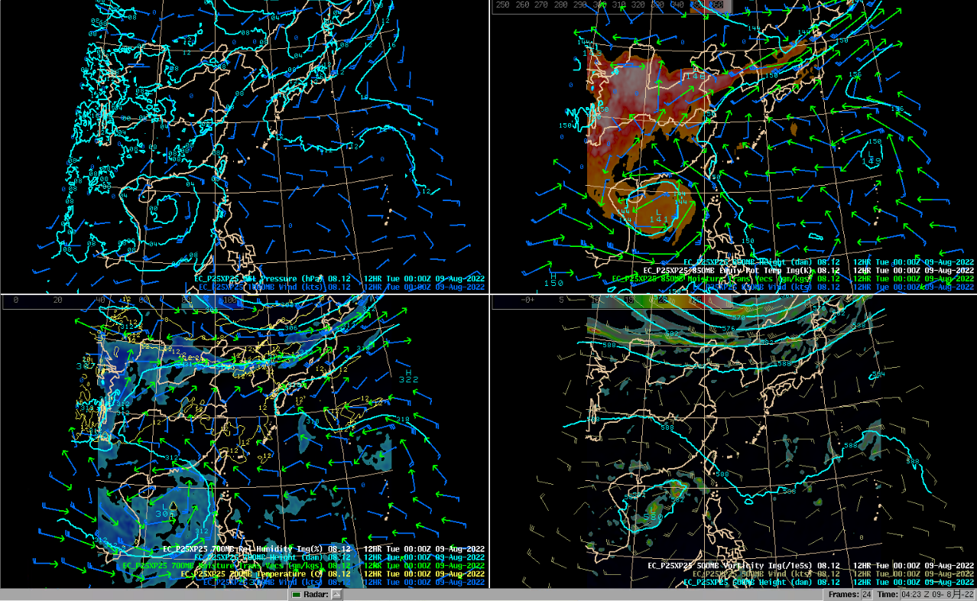
Figure 12. Synoptic field at 08/09 00z, initial time 08/08 12z (+12hr), upper left is surface pressure and 1000mb wind, upper right is 850mb wind, moisture transport, height and theta_e, lower left is 700mb wind, moisture transport, height and RH, lower right is 500mb height, wind and vorticity.
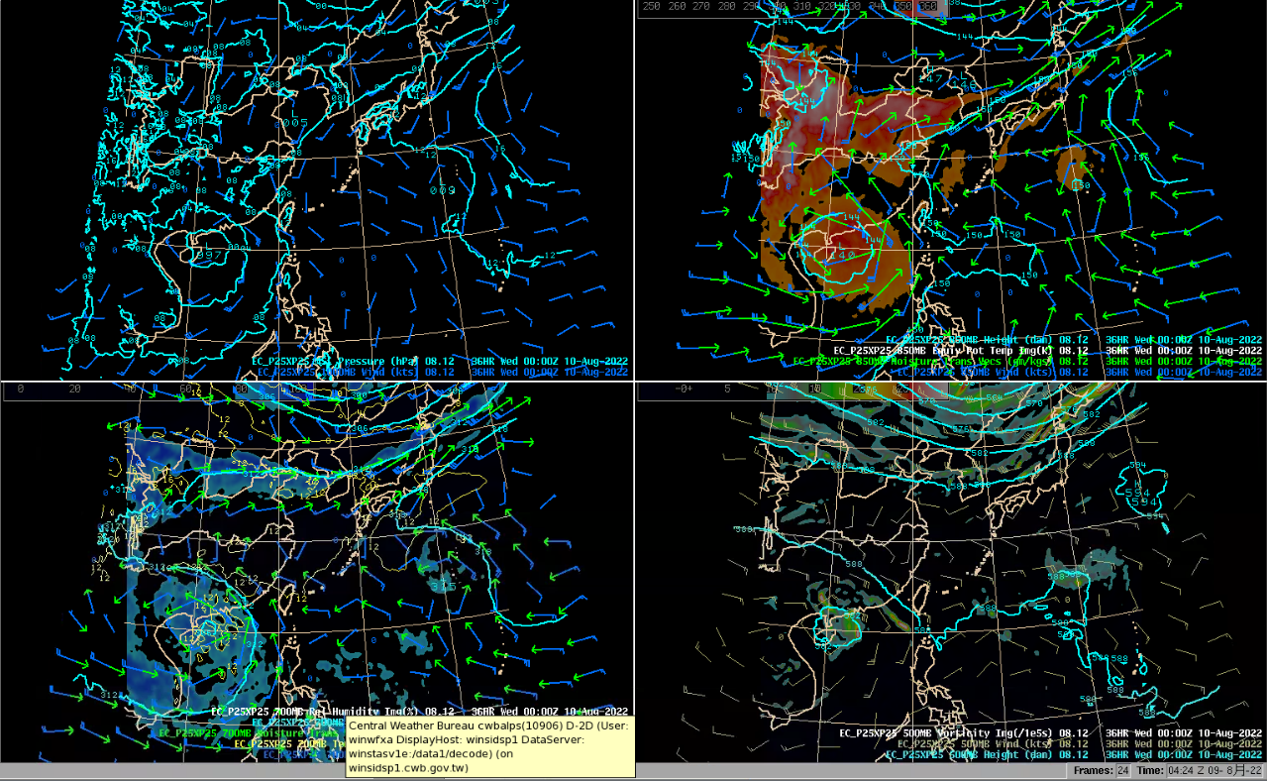
Figure 13. Synoptic field at 08/10 00z, initial time 08/08 12z (+36hr), upper left is surface pressure and 1000mb wind, upper right is 850mb wind, moisture transport, height and theta_e, lower left is 700mb wind, moisture transport, height and RH, lower right is 500mb height, wind and vorticity.
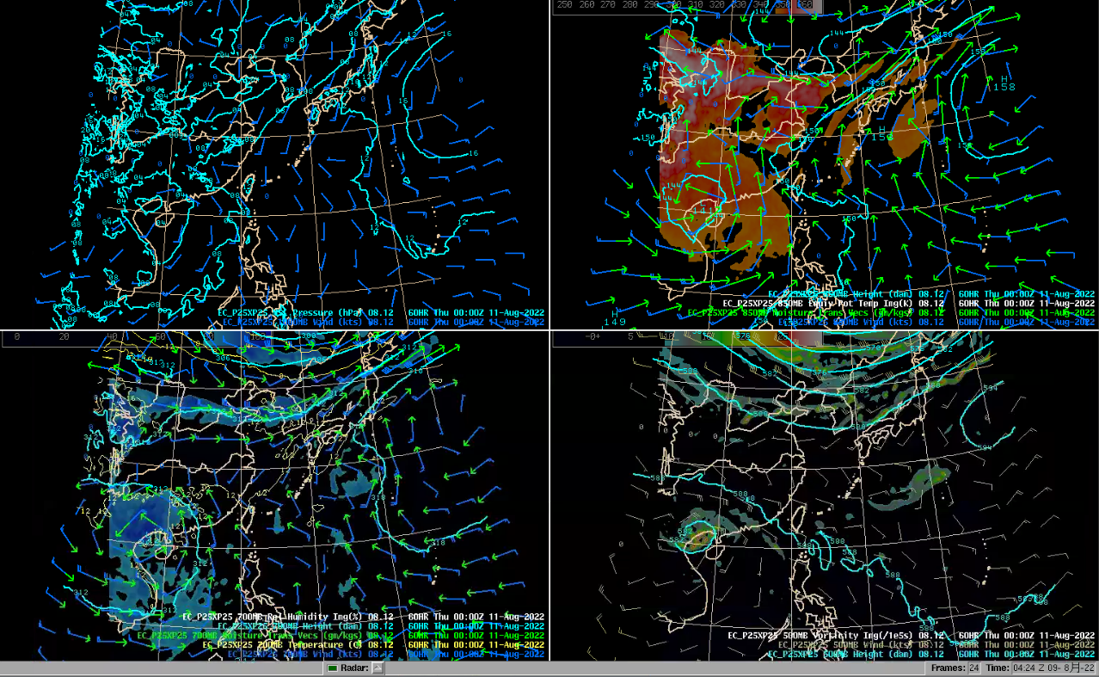
Figure 14. Synoptic field at 08/11 00z, initial time 08/08 12z (+60hr), upper left is surface pressure and 1000mb wind, upper right is 850mb wind, moisture transport, height and theta_e, lower left is 700mb wind, moisture transport, height and RH, lower right is 500mb height, wind and vorticity.
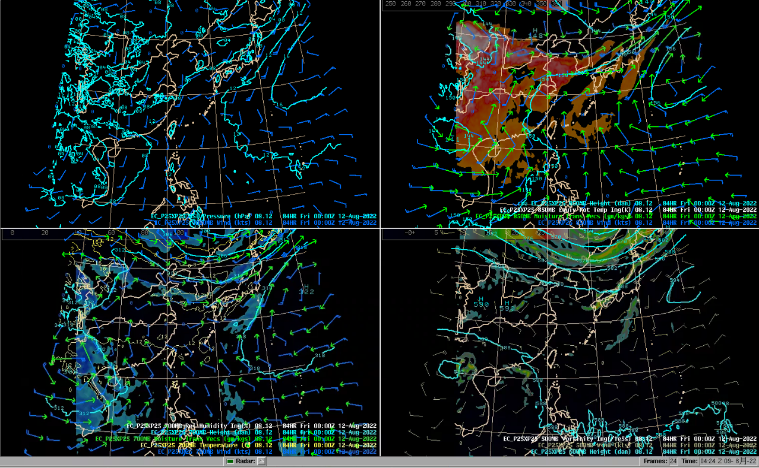
Figure 15. Synoptic field at 08/12 00z, initial time 08/08 12z (+84hr), upper left is surface pressure and 1000mb wind, upper right is 850mb wind, moisture transport, height and theta_e, lower left is 700mb wind, moisture transport, height and RH, lower right is 500mb height, wind and vorticity.
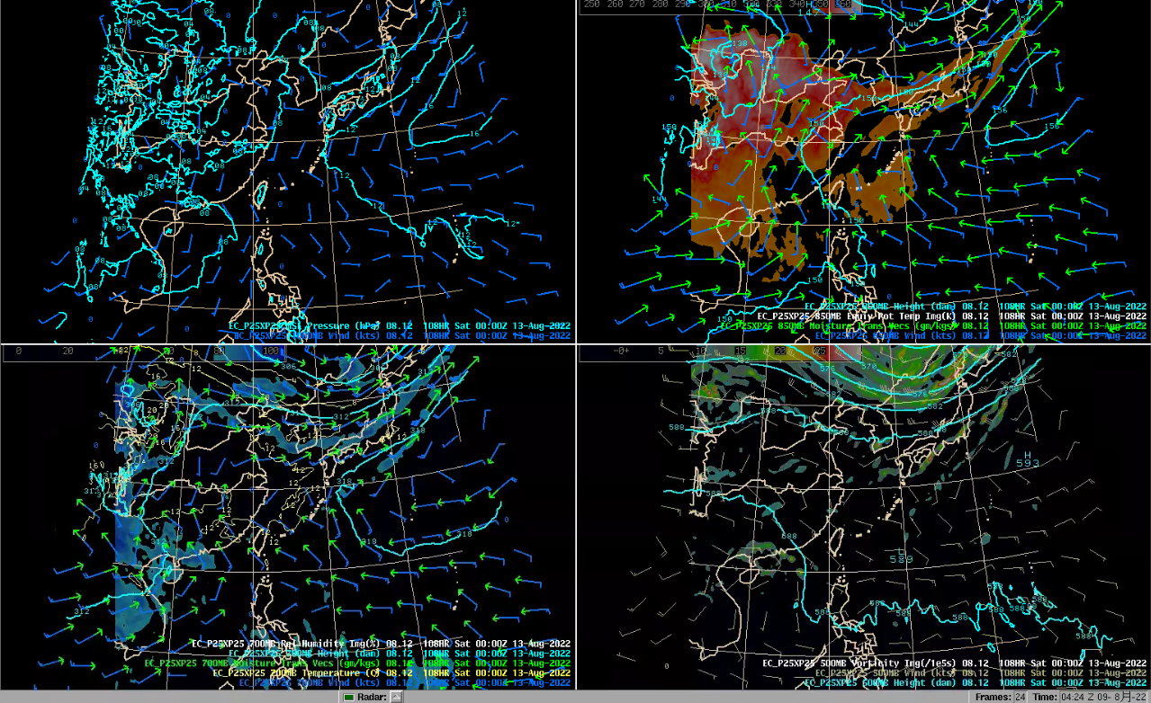
Figure 16. Synoptic field at 08/13 00z, initial time 08/08 12z (+108hr), upper left is surface pressure and 1000mb wind, upper right is 850mb wind, moisture transport, height and theta_e, lower left is 700mb wind, moisture transport, height and RH, lower right is 500mb height, wind and vorticity.

Figure 17. QPF Verification (initial at 08/08 00Z, forecast time: 08/08 00-12Z)
- observation
OBS
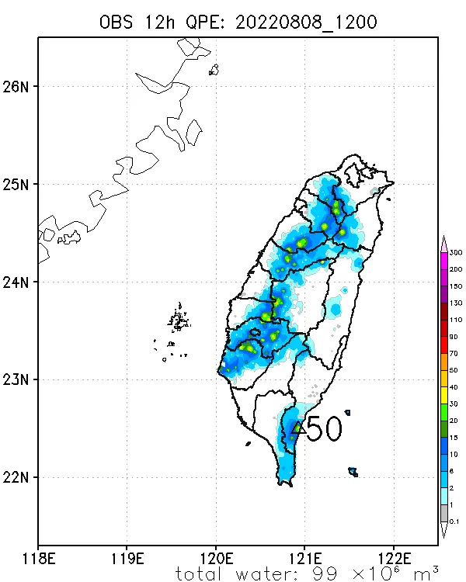

- models
EC | NCEP
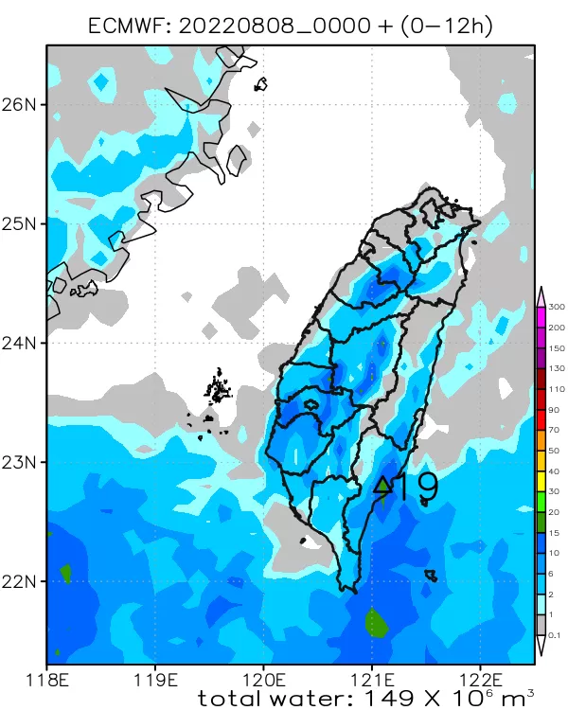 | 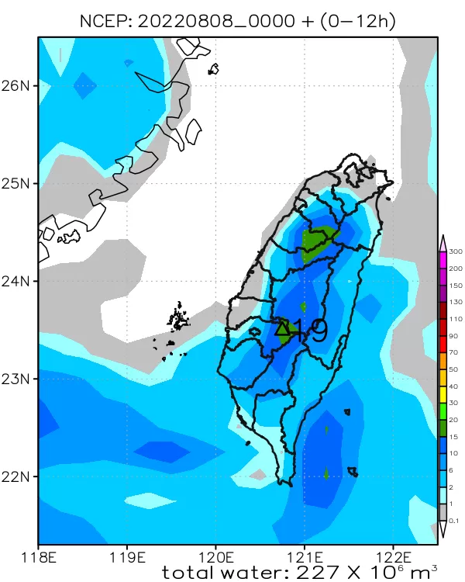
WRFD | TWRF
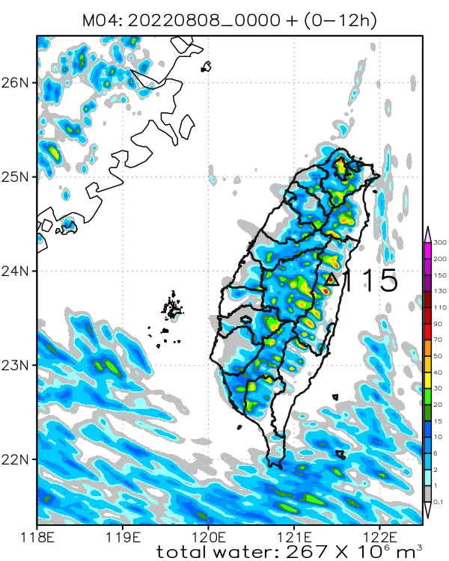 | 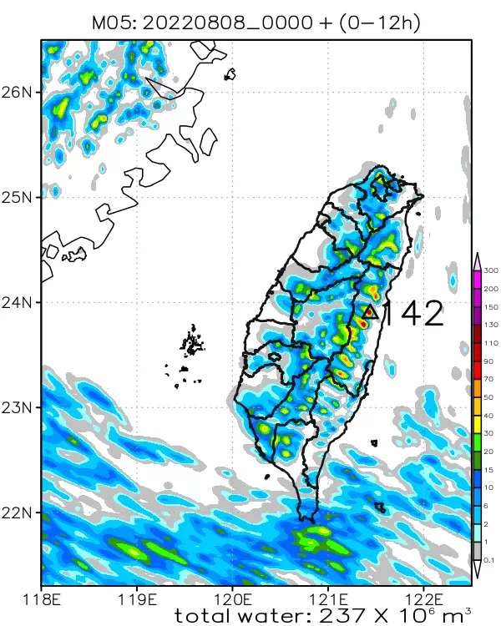

Figure 18. QPF Forecast (08/09 ~ 08/13, initial at 08/09 18Z except for EC. EC initial at 08/08 12Z)

- 08/09 00-12Z
EC | NCEP
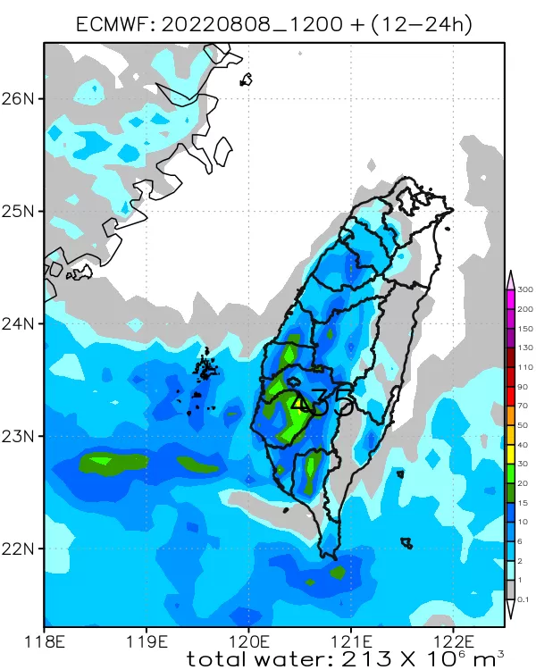 | 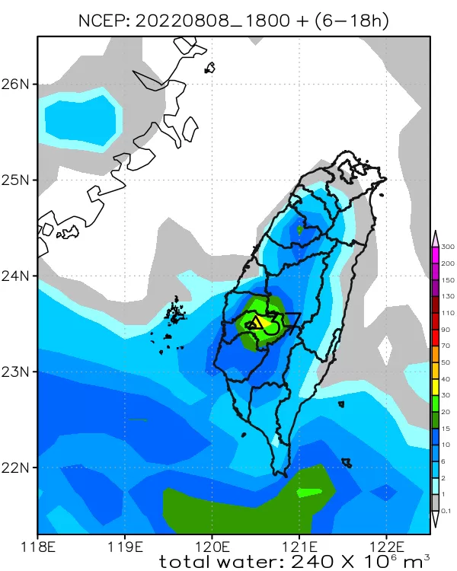
WRFD | TWRF
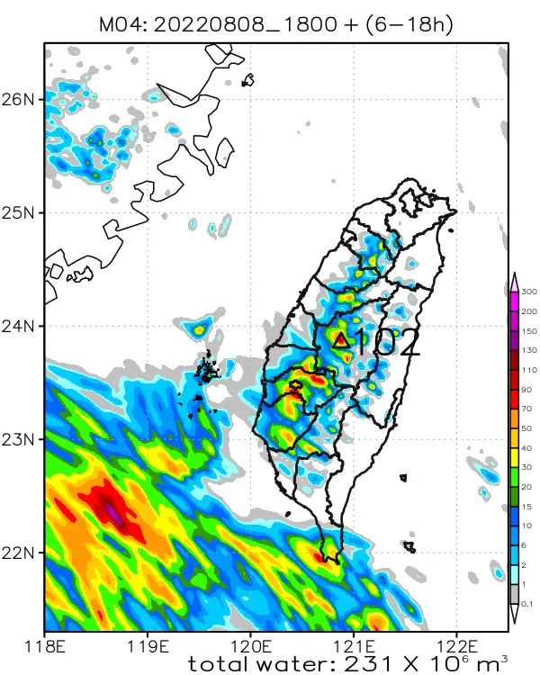 | 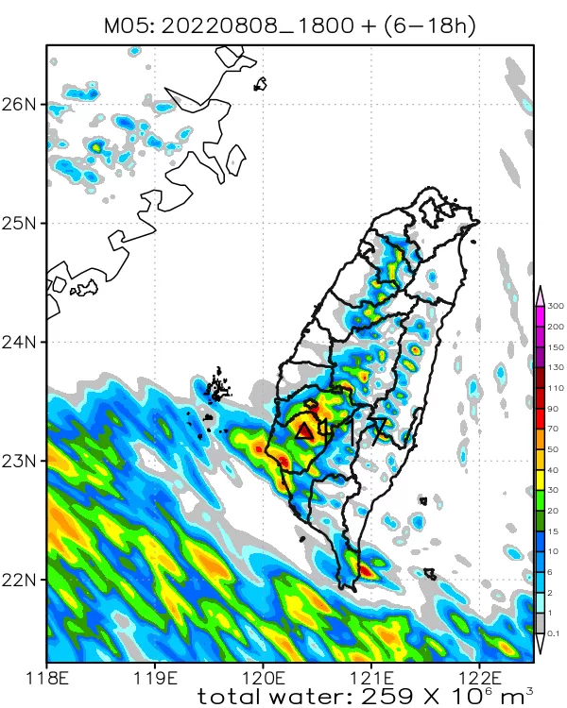

- 08/10 00-12Z
EC | NCEP
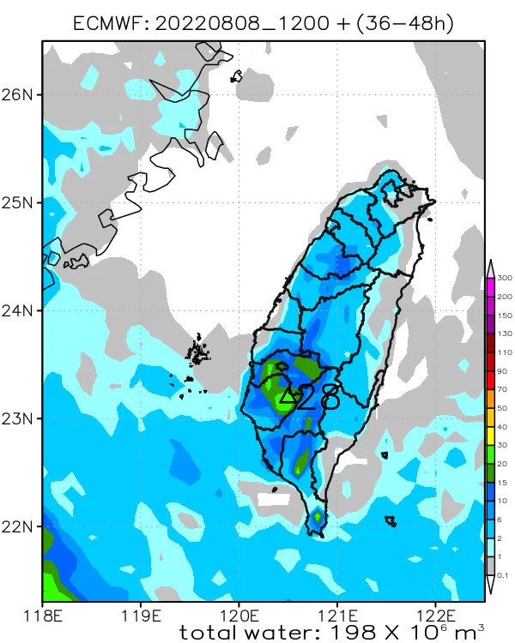 | 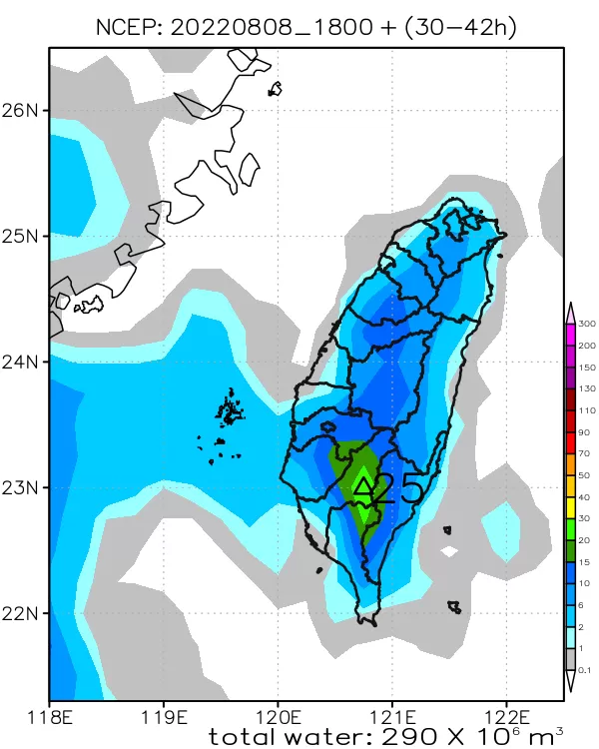
WRFD | TWRF
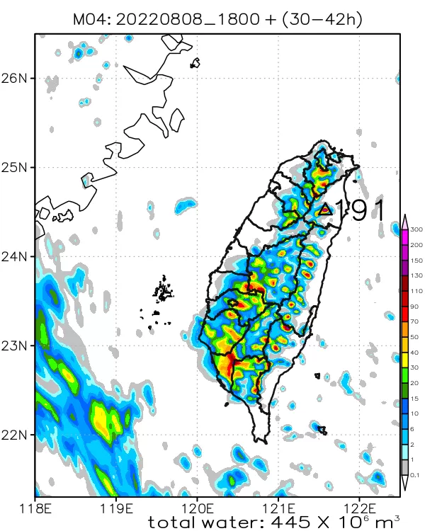 | 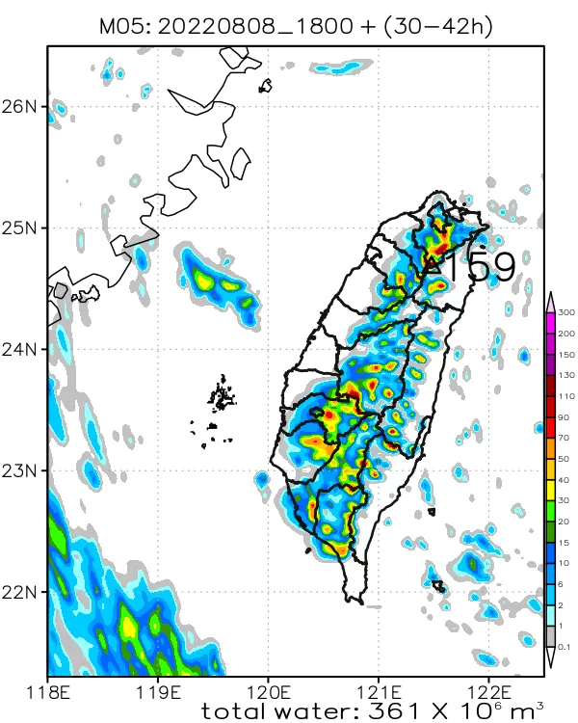

- 08/11 00-12Z
EC | NCEP
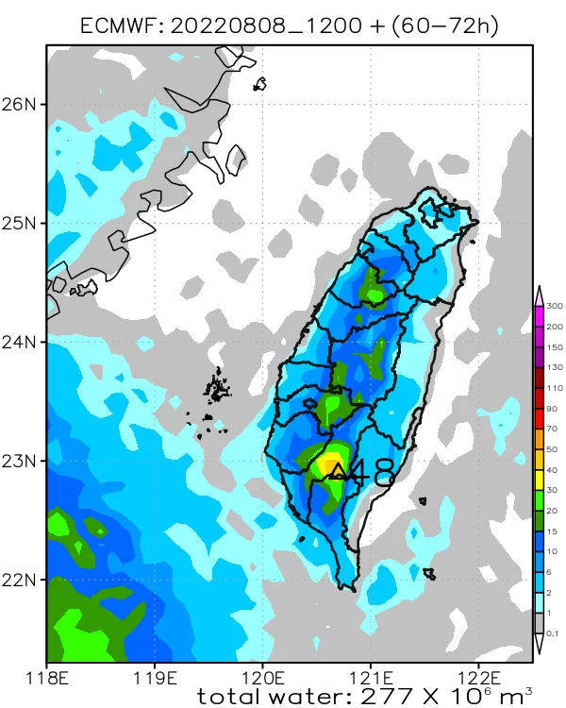 | 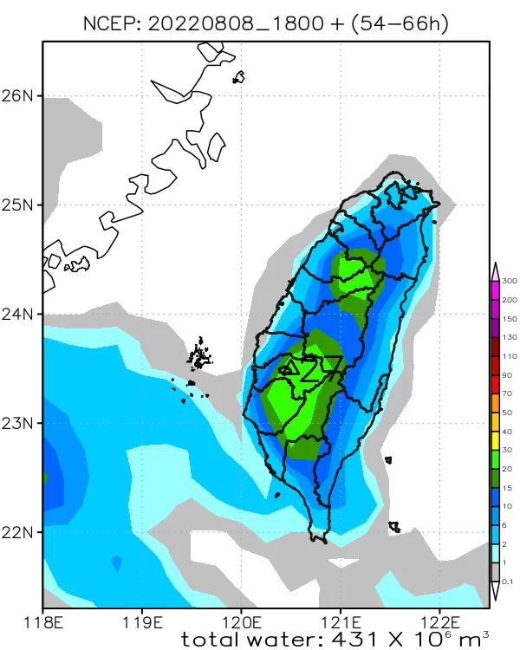
WRFD | TWRF
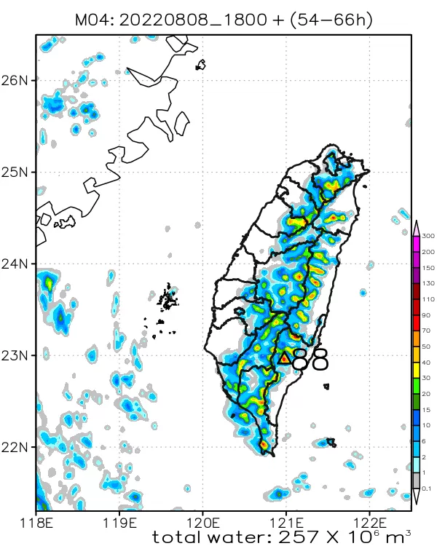 | 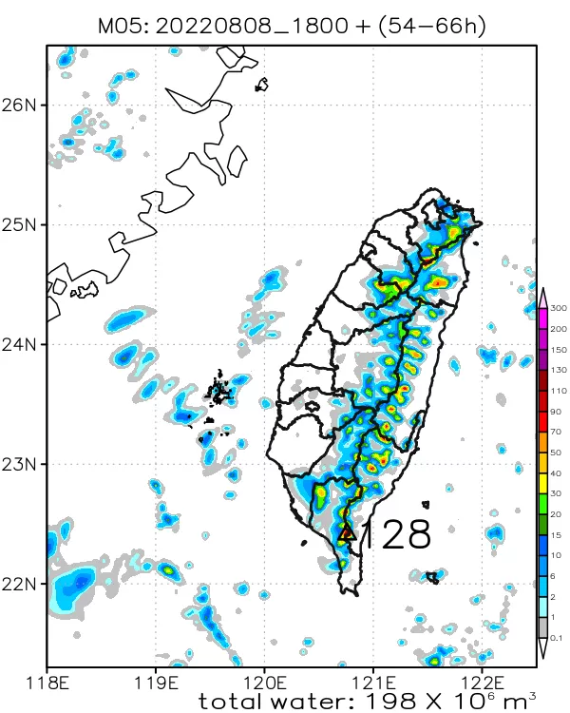

- 08/12 00-12Z
EC | NCEP
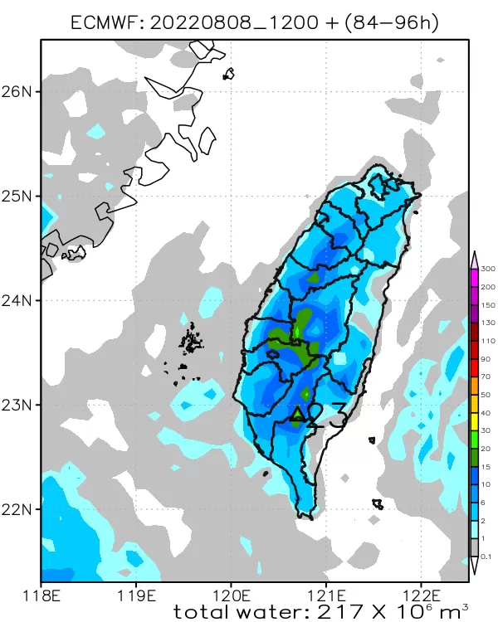 | 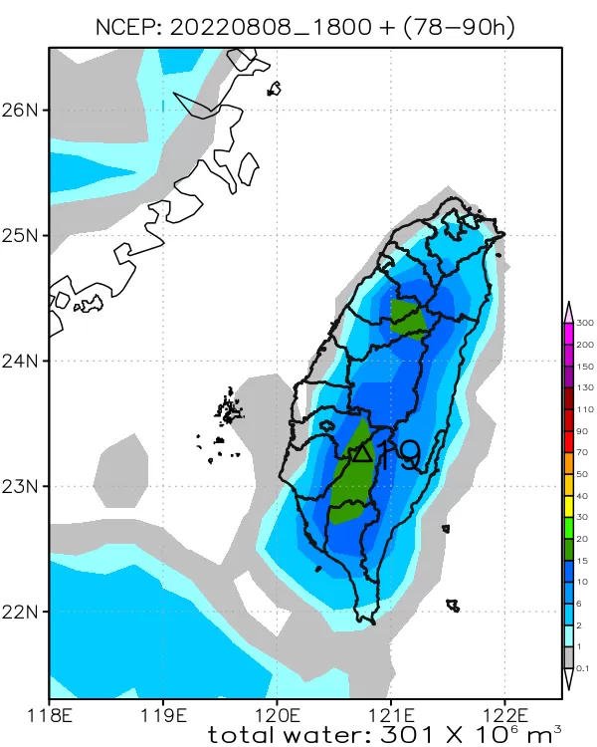
WRFD | TWRF
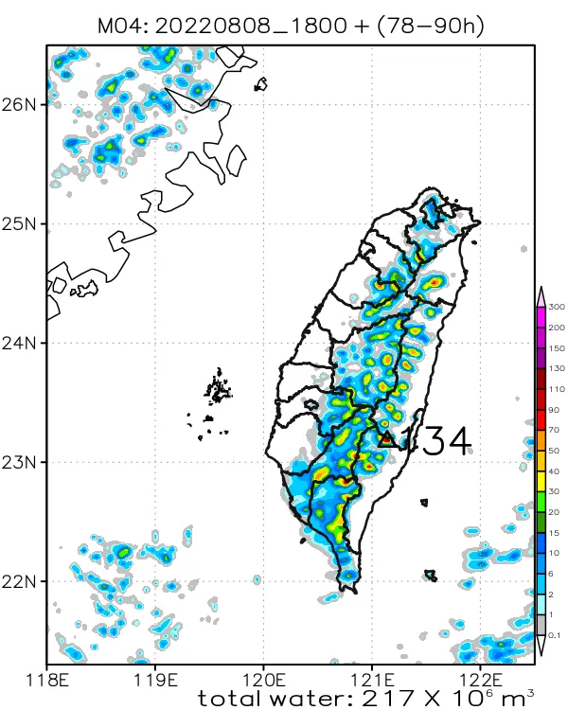 | 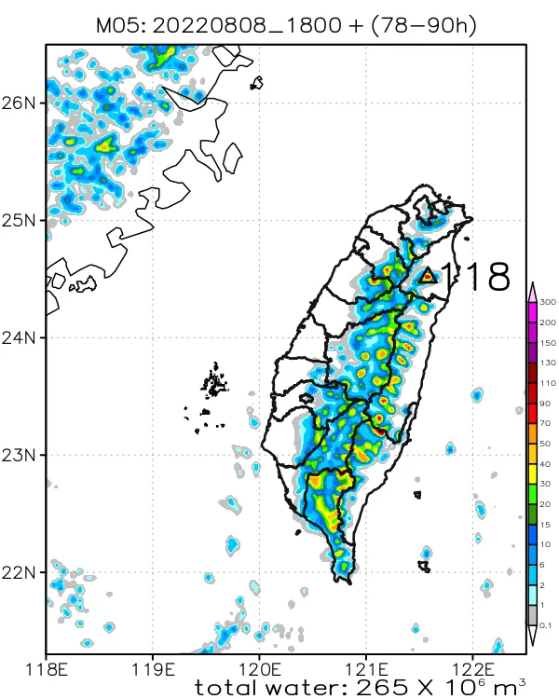

- 08/13 00-12Z
EC | NCEP
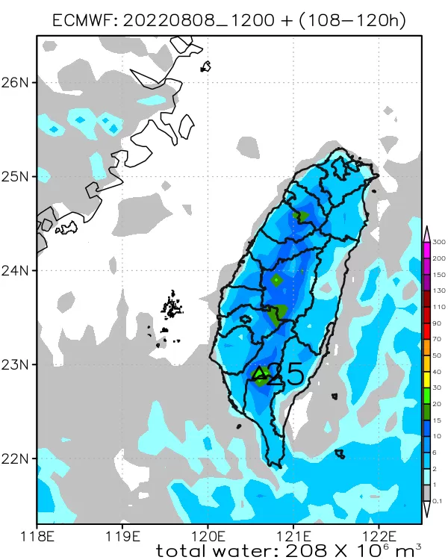 | 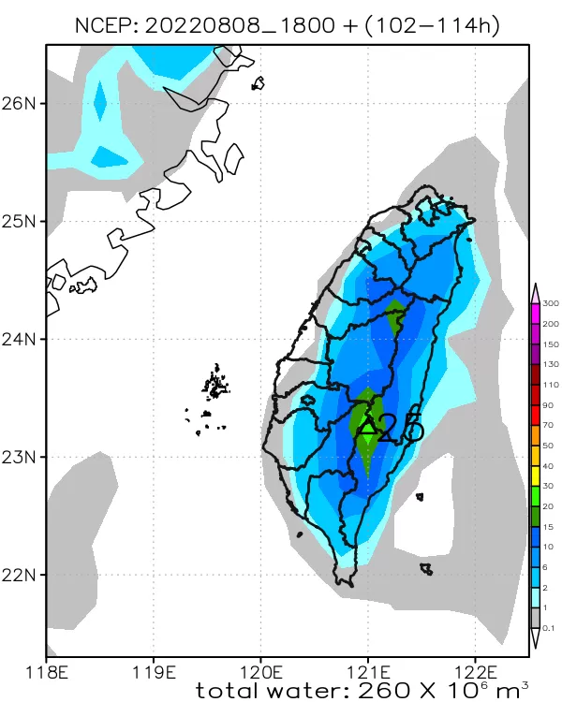
WRFD | TWRF
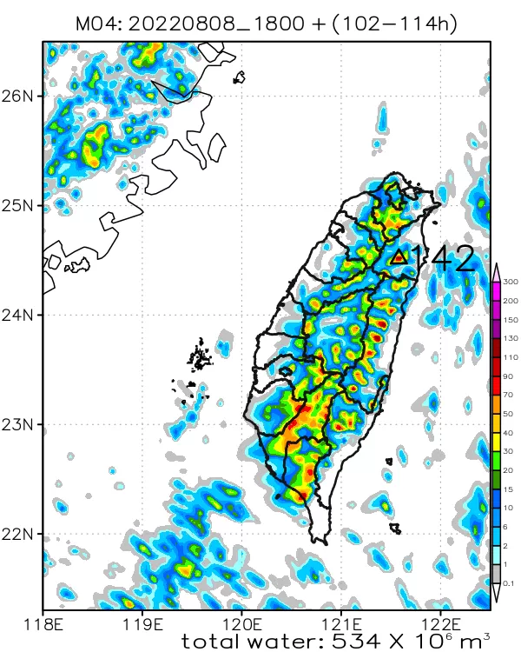 | 